Command Reference: ReadMODSIM()
Read all time series from a MODSIM output file
Version 08.16.04, 2008-09-09

The ReadMODSIM() command reads all the time series in a MODSIM output file (see the MODSIM Input Type Appendix). The actual reading occurs as the commands are being processed.

The following dialog is used to edit the command and illustrates the syntax for the command. Use the TS Alias = ReadMODSIM() command to read a single time series from a MODSIM file.

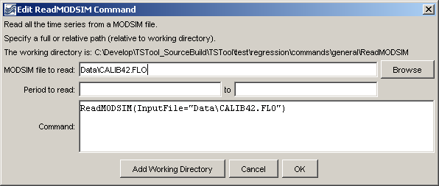
ReadMODSIM
ReadMODSIM() Command Editor

The command syntax is as follows:

ReadMODSIM(Parameter=Value…)

Command Parameters

Parameter | Description | Default
InputFile | The name of the MODSIM file to read, surrounded by double quotes. The path to the file can be absolute or relative to the working directory. | None – must be specified.
InputStart | The start of the period to read data, specified to the precision of the dates used with data. | Use the global query period.
InputEnd | The end of the period to read data, specified to the precision of the dates used with data. | Use the global query period.

A sample command file is as follows:

ReadMODSIM(InputFile="Data\CALIB42.FLO")

