Command Reference: FillRepeat()
Fill missing time series data by repeating known data values
Version 08.15.00, 2008-05-04

The FillRepeat() command fills missing data in time series by repeating observations until another observation is found. This fill technique is useful, for example, where time series are likely to be step-wise or nearly constant, such as some reservoir and diversion time series.

The following dialog is used to edit the command and illustrates the syntax of the command.

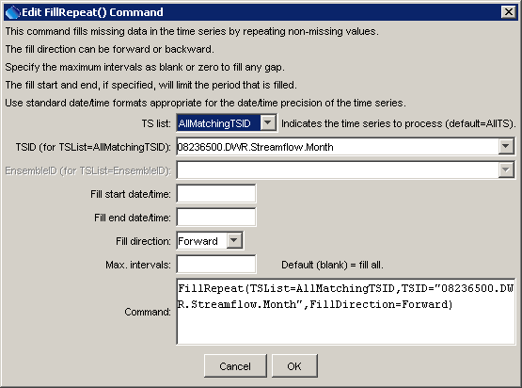
FillRepeat
FillRepeat() Command Editor

The command syntax is as follows:

FillRepeat(Parameter=Value,…)

Command Parameters

Parameter | Description | Default
TSList | Indicates the list of time series to be processed, one of:  - AllMatchingTSID – all time series that match the TSID (single TSID or TSID with wildcards) will be modified.  - AllTS – all time series before the command.  - EnsembleID – all time series in the ensemble will be modified.  - LastMatchingTSID – the last time series that matches the TSID (single TSID or TSID with wildcards) will be modified.  - SelectedTS – the time series are those selected with the SelectTimeSeries() command. | AllTS
FillStart | The starting date/time for the fill. | Available period.
FillEnd | The ending date/time for the fill. | Available period.
FillDirection | Specify the direction of the fill as Forward or Backward. | Forward
MaxIntervals | The maximum number of intervals to fill in a data gap. | Fill entire gap.

A sample command file to fill a time series from the State of Colorado’s HydroBase is as follows:

# 08236500 - ALAMOSA RIVER BELOW TERRACE RESERVOIR
08236500.DWR.Streamflow.Month~HydroBase
FillRepeat(TSList=AllMatchingTSID,TSID="08236500.DWR.Streamflow.Month",
FillDirection=Forward)

