Command Reference: RunningAverage()
Convert time series data to running average values
Version 09.07.02, 2010-08-19

The RunningAverage() command converts a time series’ raw data values to a running average, resulting in data that are smoothed. New time series are NOT created. There are two versions of the command. The centered running average requires that the number intervals on each site of a point be specified (e.g., specifying 1 will average 3 values at each point). The N-year running average is computed by averaging the current year and N - 1 values from previous years, for a specific date. An average value is produced only if N non-missing values are available. Currently N-year running average values for Feb 29 for daily or finer data will always be missing because a sufficient number of values will not be found – an option may be added in the future to allow Feb 29 values to be computed based on fewer than N values.

The following dialog is used to edit the command and illustrates the centered running average command syntax.

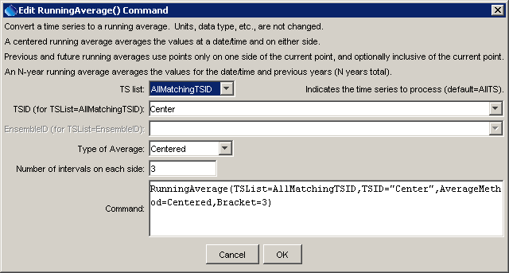
RunningAverage_centered
RunningAverage() Command Editor for Centered Running Average

The following dialog illustrates the N-year running average command syntax.

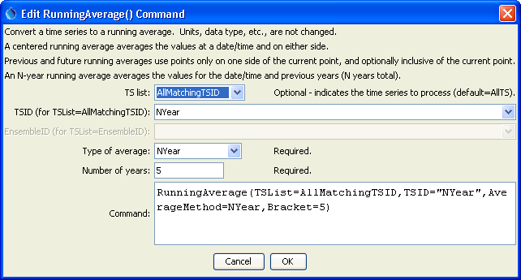
RunningAverage_nyear
RunningAverage() Command Editor for N-Year Running Average

The command syntax is as follows:

RunningAverage(Parameter=Value,…)

Command Parameters

Parameter | Description | Default
TSList | Indicates the list of time series to be processed, one of:  - AllMatchingTSID – all time series that match the TSID (single TSID or TSID with wildcards) will be modified.  - AllTS – all time series before the command.  - EnsembleID – all time series in the ensemble will be modified.  - LastMatchingTSID – the last time series that matches the TSID (single TSID or TSID with wildcards) will be modified.  - SelectedTS – the time series are those selected with the SelectTimeSeries() command. | AllTS
TSID | The time series identifier or alias for the time series to be modified, using the * wildcard character to match multiple time series. | Required if TSList=*TSID.
EnsembleID | The ensemble to be modified, if processing an ensemble. | Required if TSList= EnsembleID.
AverageMethod | The method used to create the running average, one of:  - Centered – values on each side of a date/time are averaged.  - Future – average the next N (bracket) values but do not include the current value.  - FutureInclusive – average the next N (bracket) values and also include the current value.  - N-Year – values for the current year and (N – 1) preceding years, for the same date/time, are averaged.  - Previous – average the previous N (bracket) values but do not include the current value.  - PreviousInclusive – average the previous N (bracket) values and also include the current value. | None – must be specified.
Bracket | For centered running average, the bracket is the number of points on each side of the current point (therefore a value of 1 will average 3 data values). For N-year running average, the bracket is the total number of years to average, including the current year. | None – must be specified.

A sample command file to convert State of Colorado HydroBase diversion time series to running averages is as follows:

# 0100501 - EMPIRE DITCH
TS Center = readTimeSeries("0100501.DWR.DivTotal.Month~HydroBase")
RunningAverage(TSList=AllMatchingTSID,TSID="Center",
AverageMethod=Centered,Bracket=3)
TS NYear = readTimeSeries("0100501.DWR.DivTotal.Month~HydroBase")
RunningAverage(TSList=AllMatchingTSID,TSID="NYear",
AverageMethod=NYear,Bracket=5)
0100501.DWR.DivTotal.Month~HydroBase

The resulting graph is as follows:

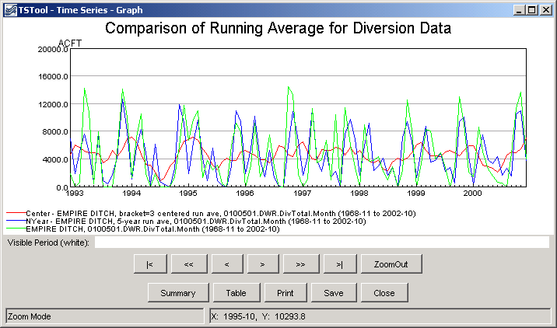
RunningAverage_graph
Results from RunningAverage() Commands

