**Configuring TSTool to interface with a Microsoft Access Database using ODBC**

Last updated: 2013-12-22

TSTool can be configured to interface with a Microsoft Access database using an Open Database Connectivity Data Source Name (ODBC DSN). When configuring the ODBC DSN success will depend on:

1. The ODBC configuration tool being run
2. The ODBC drivers that are installed and recognized by the configuration tool
3. The Access database that is selected
4. The Java version that is being used to run TSTool

Unfortunately, the above combination can result in mismatches between 32-bit and 64-bit databases, drivers and software, and Microsoft ODBC 64-bit software is not seamlessly compatible with 32-bit versions. This document attempts to explain and help resolve issues. The information is presented by topic area in common order that configuration and troubleshooting would occur and troubleshooting may involve one or more topics.

**Defining an ODBC DSN**

An ODBC DSN is generally configured using the Control Panel…Administrative Tools…Data Sources (ODBC) tool. By default, the version of the configuration tool that is run will match the operating system (e.g., 64-bit tool will be run on a 64-bit Windows 7 installation – even if Office software installed the 32-bit version – is this true?). However, this may result in incompatibilities with the database driver. As a first step, assume that the default tool can be used to define an ODBC DSN. First, start the tool, which will show a dialog as follows. User DSN are accessible only to a specific user and System DSN are accessible to all users on the computer.

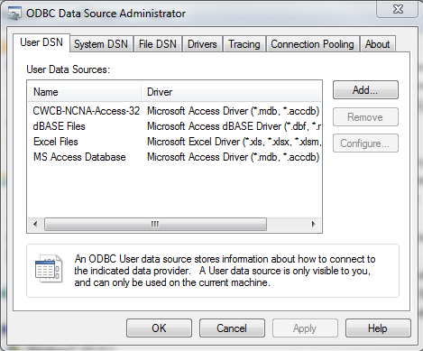

**Figure 1 – Listing of User ODBC DSN**

The information shown in Figure 1 is a bit confusing in that it lists defined ODBC DSN (such as the first entry) as well as generic drivers. To define a new connection, click on **Add…**, which shows a dialog as shown in Figure 2 (or double-click on the data source type in Figure 1, for example MS Access Database).

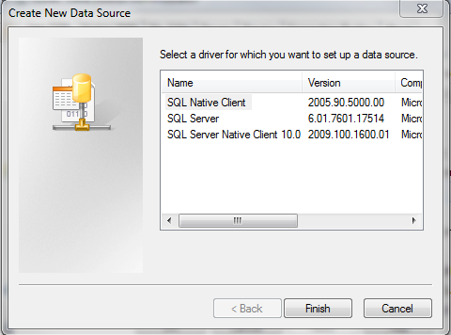

**Figure 2 – Create New Data Source (ODBC DSN) Dialog**

Figure 2 illustrates that in this case, the computer (which happens to be running 64-bit Windows 7) only has 64-bit ODBC drivers installed for SQL Server. Note that the default when installing Microsoft Office on 64-bit computers is that 32-bit versions of Access, Word, Excel, etc., are installed). On 64-bit Windows, run the 32-bit tool to define 32-bit ODBC DNS connections:

C:\Windows\SysWOW64\odbcad32.exe

To help avoid confusion, it is recommended that the ODBC DSN name include “32” as in the example in Figure 1. Once the ODBC DSN is defined, it also will be listed in the 64-bit tool (as shown in Figure 1) but only the 32-bit tool should be used to edit (is this correct?).

If a suitable driver is not listed, try installing the ODBC drivers for the Microsoft Word version (32-bit or 64-bit).

1. First, if the Windows Task Manager is run to list processes, it is possible to determine if Microsoft Access is 32-bit or 64-bit (does this depend on what Access file is opened?). For example, double-click on a *.mdb file and then look for a corresponding Microsoft Access process in the Task Manager process list. If the Microsoft Access process is listed with *32 at the end, then a 32-bit process is running and the ODBC DSN associated with the database will be using the 32-bit configuration tool (is this true?).
2. The ODBC DSN drivers for Access may not installed by default even if Access is installed and definitely won’t be installed on computers that don’t have Access installed. To make Access available to other programs on the computer, it is necessary to install the “Microsoft Access Database Engine NNNN Redistributable”, where NNNN is the software version such as 2010 or 2013. The following download pages are available on the Microsoft website. It is recommended to install the version that is compatible with the Microsoft Office (note that by default 32-bit versions of Office software are installed even if installing on a 64-bit Windows 7 computer). According to the Microsoft Access 2013 Runtime instructions: “Download the file by clicking Download and saving the file to your computer. Choose the version (x86 or x64) that matches the target Office installation.”
   1. 2010: <http://www.microsoft.com/en-us/download/details.aspx?id=13255>
   2. 2013: <http://www.microsoft.com/en-us/download/details.aspx?id=39358>
3. After installing the redistributable, repeat trying to define the ODBC DSN using the appropriate ODBC DSN (32-bit or 64-bit) administration tool for the computer. Then try accessing with TSTool as shown in the following sections.

**Datastore Configuration**

A TSTool datastore can be configured to interface with an Access database using the GenericDatabaseDataStore datastore type. For example, include the following in the TSTool.cfg file (the 32 in this case indicates that a 32-bit ODBC DSN was configured – more about this in following sections):

[DataStore:CWCB-NCNA-Access-32]

ConfigFile = "CWCB-NCNA-Access-32.cfg"

And create a datastore configuration file similar to:

# Configuration information for CWCB NCNA Access database

# using generic database datastore.

#

# The user will see the following when interacting with the datastore:

#

# Name - datastore identifier used in applications, for example as the

# input type information for time series identifiers (usually a short string)

# Description - datastore description for reports and user interfaces (short phrase)

#

# The following are needed to make database connections in the software

#

# Type - must be GenericDatabaseDataStore

# DatabaseEngine - the database software (SqlServer is current standard)

# DatabaseServer - IP or string address for database server, with instance name

# (e.g., "localhost\CDSS" can be used for local computer)

# DatabaseName - database name used by the server (e.g., HydroBase_CO_20120722)

# SystemLogin - service account login (specify for HBGuest account)

# SystemPassword - service account password (specify for HBGuest account)

#

Enabled = True

Type = "GenericDatabaseDataStore"

Name = "CWCB-NCNA-Access-32"

Description = "CWCB NCNA Access 32-bit Datastore"

DatabaseEngine = "Access"

# Local SQL Server Express installation...

OdbcName = "CWCB-NCNA-Access-32"

# Login and password not needed

**Java Version**

The Java version distributed with TSTool has traditionally been the 32-bit operating system version and will run on 32-bit and 64-bit systems. However, 64-bit TSTool installations are distributed with 64-bit Java and will be indicated in the installer name. Need to indicate here how to use TSTool Help About to figure out whether 32-bit or 64-bit Java runtime is being used.

**Troubleshooting TSTool**

The following message may be output to the TSTool logfile during datastore setup if the ODBC DSN configuration is 32-bit/64-bit incompatible:

Caused by: java.sql.SQLException: [Microsoft][ODBC Driver Manager] The specified DSN contains an architecture mismatch between the Driver and Application

This error is also displayed if the 64-bit ODBC DSN administration tool is run when Access 32-bit is installed and “MS Access Database” is double-clicked on in Figure 1.

To resolve, verify that the following components are the same (32-bit or 64-bit):

* Java runtime (check version being used in development and TSTool installer)
* ODBC DSN connection (use the correct configuration tool)
* Microsoft Access executable (check the Process Manager for *32 next to the process name to indicate 32-bit).

So… is it possible to run 32-bit TSTool (the current distributable) with 64-bit Access? Maybe not. To work-around, replace the TSTool jre_16 folder with a 64-bit Java Runtime Environment (JRE). In the future, 64-bit TSTool installers for Windows will be made available.