**Summary of TSTool Integration with HDB and Reclamation Business Processes**

**Steve Malers, Last update: 2013-09-19**

**Introduction**

This working document describes Reclamation business processes relevant to HDB, in particular the definition of time series and ensembles in the HDB database. These business practices impact TSTool’s integration with HDB. Important concepts include:

1. TSTool does not define new time series or ensembles in HDB (or should it as per the GET_TSTOOL_ENSEMBLE_MRI procedure):
   1. Because of TSTool automation, user input errors might create time series erroneously
   2. TSTool command editors present users with selections for time series and ensembles so a separate dialog would be needed to create an ensemble
   3. An existing Reclamation tool should be used to define time series
2. TSTool attempts to use human-readable information to uniquely identify time series, not internal database identifiers:
3. TSTool internally stores data with date/time at the end of the data interval:
   1. Shifts are described in the Reclamation HDB Datastore Appendix. Shifts are handled so reading/writing does not alter the represenstation of data in HDB.

**How a Time Series Gets Defined in HDB**

Gets defined with POET or manually using Oracle SQL tool?

**How a a Model Run is Selected/Created in RiverWare**

These notes were supplied by Andrew Gilmore in an email 2013-08-06.

RiverWare assumes the mapping and specific time series selection is all done on a workflow basis, so these screenshots are only of the metadata selections.

1. Dataset window. The “mapping id” is how the RiversWare object slots are mapped to HDB “site datatypes”. The mapping is stored in “hdb_ext_data_source” (see contents below). Don’t see the CHPS/FEWS forecast here on the development database.

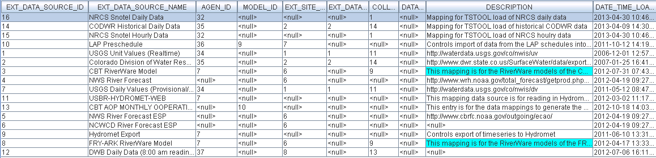

HDB_EXT_DATA_SOURCE Table

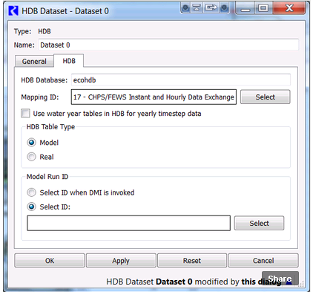

RiverWare Dataset Dialog

1. Select the Model Run ID.

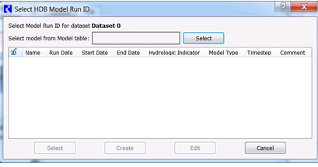

Blank Model Run ID Dialog (press Select to get a list)

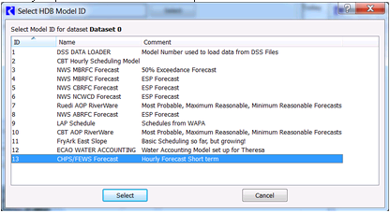

Select a Model Run ID and press Select

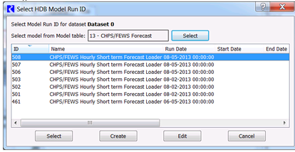

Selected Model Run ID

1. To create a new Model Run ID, select “Create” from the above dialog.

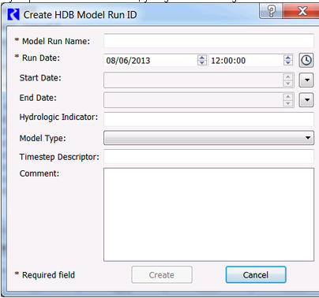

Create Model Run (initial defaults)

Note that the time is set for 12:00:00 (to second precision). The clock can be selected to populate the run date with the current time.

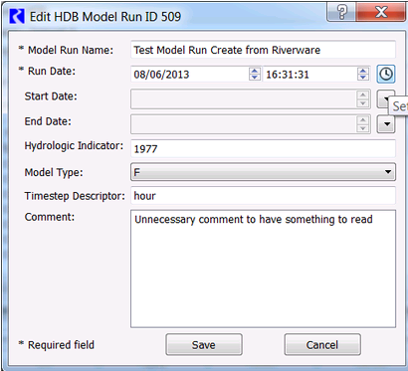

New Model Run Information

1. Complete dataset definition for HDB and RiverWare. The selected Model Run ID can be selected and used for RiverWare.

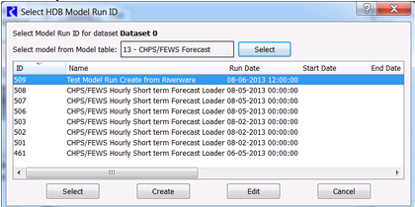

Newly created model run (with run date)

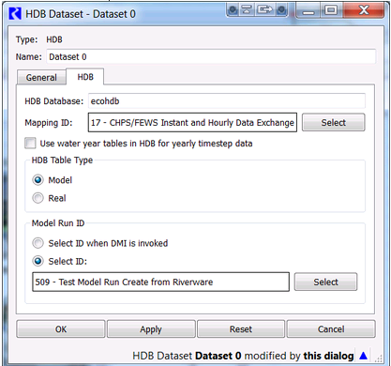

Selection of completed dataset for RiverWare run

**How an Ensemble Time Series Gets Defined in HDB**

Need to do these steps to define ensembles so that TSTool can read them and write the correct database slots.

**Reading an HDB Time Series using TSTool**

**Reading an HDB Ensemble using TSTool**

**Writing a Time Series to HDB Using TSTool**

**Writing an Ensemble to HDB Using TSTool**