How to associate .TSTool extension with TSTool software

2016-02-20

This document provides information about associating the .TSTool file extension with the latest installed version of TSTool, on Windows computers. The installer normally does this automatically but this manual approach may be needed when TSTool is installed on a server.

In Windows, double-clicking on a file extension will try to run a program that knows how to process the associated file. TSTool uses the *.TSTool file extension. Double-clicking on a *.TSTool file in Windows Explorer may display the following:

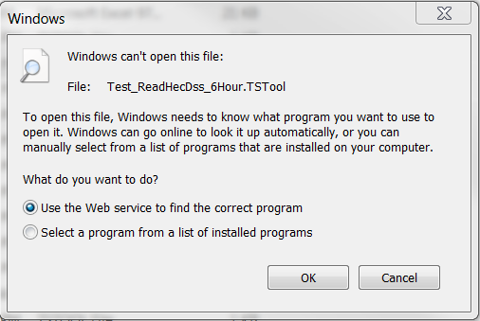

It is desirable to associate TSTool with the extension. However, TSTool is installed in a versioned folder to allow different versions to be run. This allows transition from one version to another to have a safety net in cases where the newest version does not work for old command files (this is rare but could happen). The versioning means that a specific version of the software will be associated with the file extension and an old version could be used unexpectedly.

To address this issue, do the following:

1. Create a folder C:\CDSS\TSTool-latest
2. Create a folder C:\CDSS\TSTool-latest\bin
3. Put the following script into a file named tstool.bat in the above folder. The installation location for TSTool should be changed appropriately, for example, put the server install location.

|  |
| --- |
| @echo off  rem Script to figure out the latest (newest) TSTool and run the tstool.exe in that folder.  rem This allows using the PATH and file extension association to automatically  rem recognize the latest version .  rem See: http://stackoverflow.com/questions/10519389/get-last-created-directory-batch-command  rem The following works to return the newest install but may not be correct  rem if an old version is re-installed.  rem  rem /b is for bare format  rem /ad-h lists non-hidden directories  rem t:c sort by creation date  rem /od sort oldest first  rem FOR /F "delims=" %%i IN ('dir "c:\CDSS\TSTool-*" /b /ad-h /t:c /od') DO SET a=%%i  rem The following works sorting alphabetically on install folder name since  rem zero-padded version numbers will cause proper sort>  rem Ignore "TSTool-latest" because that is the special folder that this script is in.  FOR /F "delims=" %%i IN ('dir "c:\CDSS\TSTool-*" /b /ad-h /on') DO (  if not %%i == TSTool-latest SET a=%%i  )  rem Now run TSTool with all the original command line parameters  rem The following works better to find dlls, etc. that need to be loaded  c:  cd \CDSS\%a%\bin  tstool.exe %*  rem The following does not load HEC-DSS dlls properly  rem C:\CDSS\%a%\bin\tstool.exe %* |

1. Complete the association in the above dialog by selecting “Select a program from a list of installed programs” and then selecting the batch file by using the “Browse…” button.

This solution will ensure that double-clicking on a file with *.TSTool extension will always load the command file in the latest installed version of TSTool.