TSTool Point Flow Analysis Quick Start Guide

2014-04-15

# Introduction

This document provides an overview of how to perform a “point flow” analysis using the TSTool software, as well as indicating potential interaction with other point flow analysis tools. After reading this document you should understand point flow analysis concepts and have enough understanding to begin implementing an analysis. You may also choose to use TSTool selectively, for example to pre-process time series as input to another point flow analysis tool.

# Point Flow Analysis Background

The intent of a point flow analysis is to calculate flow and other values within a stream system using simple mass balance calculations. A point flow analysis approach is somewhere in the middle of the modeling spectrum in terms of complexity:

* Summary mass balance – add all inputs and outputs in gross terms
* Point flow analysis – represent important points, time steps are solved independently
* System model – conceptualize system, one time step may impact others

For each analysis approach, it is necessary to represent the physical system in a conceptual way that corresponds to available data. A typical point flow analysis represents the system as a series of nodes, each of which has a single downstream node (the exception being the end node, which has no downstream node). This representation and mass balance calculations are shown in the following figure.



Point Flow Analysis Netwoork and Calculations

The solid circles represent known point flow locations, typically stream gages where flow is measured to a reasonable accuracy. The hollow circles represent intervening points where water is subtracted (e.g., at a diversion to agriculture), added (e.g., at an inflow point such as a municipal wastewater treatment plant), or left unchanged (e.g., an instream flow reach for environmental flows). Simple mass balance calculations can be performed for each stream reach (defined as the stream between gages) starting with the upstream known flows at the gage(s), and then move downstream to subtract diversions and add inflows. The resulting accumulated error when compared with the downstream known flow (gage) is the error over the entire stream reach. If the error is positive, it means that the stream is gaining. If the error is negative, it means that the stream is losing. Gains and losses are due to groundwater interactions and other additions and subtractions that are not explicitly accounted for in the analysis. In order to make the numbers balance in the reach the error at the downstream point must be distributed back to other nodes in the reach.

Fundamental data inputs required for a point flow analysis include:

1. System representation (the network)
2. Time series associated with nodes
3. Calculation rules for nodes

System Representation

Two representations of the network are discussed in the following sections, one from Excel, and one from the StateMod model used in Colorado’s Decision Support Systems. In each case, the following basic data is needed for each node in the network:

* Node identifier (ID), for example stream gage ID
* Node name, for example stream gage name, useful for visualization
* Node type, for example whether a stream gage, diversion, inflow
* Downstream node, to provide network connectivity

Additional optional node data include:

* Stream mile, needed to prorate gains and losses by distance
* Gain/loss weight, if distributing the gains and losses by weighting node values
* Information used to identify the time series data

Time Series

Time series of the appropriate data type must be associated with the nodes in order to perform the mass balance calculations. TSTool provides commands to read time series given a list of node identifiers and other information, as illustrated further in the following sections. The time series are then associated with the node based on the identifier. Consequently, the network and time series identifier must be the same.

Calculation Rules

Point flow calculation rules for each node are based on the node type. For example, diversion nodes subtract the diversion amount from the streamflow at the node. Inflow nodes add the inflow to the streamflow amount. More complex calculation rules are possible. For example, if a diversion is known to dry the river, then the diversion essentially becomes a temporary stream gage with a known flow of zero. The TSTool point flow analysis tool does not support this capability at this time.

# Spreadsheet Network Representation

It is convenient to represent a river network in a spreadsheet as shown in the following figure.

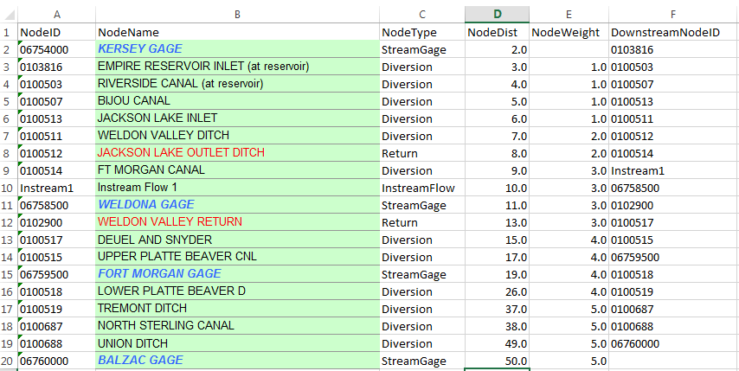

AnalyzeNetworkPointFlow_InputTable

Spreadsheet Network Representation

In the above example, the network connectivity is defined by NodeID and DownstreamNodeID. A summary of each column is as follows:

NodeID – location identifier for the node in the network (will match with time series)

NodeName – location identifier for the node, useful for labels and visualization

NodeType – distinct types that are matched to the calculation rules

NodeDist – stream distance from some reference location, used to distribute gain/loss

NodeWeight – weight that can be used to distribute gain/loss

DownstreamNode – node that is downstream from the current node, to define the network

Additional columns may be appropriate, for example to specify time series metadata for reading time series, comments about the node, etc.

The above spreadsheet representation can be read in TSTool using the ReadTableFromExcel() command and is used as input to the point flow analysis.

# StateMod Model Network Representation

An alternative to a spreadsheet representation of the network is to use an input file from a basin model that includes a stream network definition. For example, the StateMod model that is part of Colorado’s Decision Support Systems uses a river network file (*.rin) with contents similar to the following Colorado River data set cm2009.rin file. Note that structure water district identifiers are 6-digits (e.g., 514601) whereas the standard for CDSS is 7 digits (e.g., 5104601).

|  |
| --- |
| #> StateMod River Network File  #> WARNING - if .net file is available, it should be edited and the .rin  #> file should be created from the .net  #>  #> format: (a12, a24, a12, 1x, a12, 1x, f8.0)  #>  #> ID cstaid: Station ID  #> Name stanam: Station name  #> Downstream cstadn: Downstream node ID  #> Comment comment: Alternate identifier/comment.  #> GWMax gwmaxr: Max recharge limit (cfs) - see iwell in control file.  #>  #> ID Name DownStream Comment GWMax  #>---------eb----------------------eb----------exb----------exb------e  #>EndHeader  514601 GRAND RIVER DITCH _DIV09010500 514601 -999  09010500 COLORADO RIVER BELOW_FLO512068 09010500 -999  512068 MIN FLOW N FK COLORA_ISF510848 512068 -999  510848 REDTOP VALLEY DITCH _DIV512068_Dwn 510848 -999  512068_Dwn _OTH09011000 512068_Dwn -999  09011000 COLORADO RIVER NEAR _FLO513695 09011000 -999  513695 CBT SHADOW MTN GRAND_RES514634 513695 -999  514634 CBT ALVA B ADAMS TUN_DIV953695 514634 -999  953695 SHADOW MTN RES BYPAS_ISF953695_Dwn 953695 -999  953695_Dwn _OTH512069 953695_Dwn -999  512069 MIN FLOW COLORADO R _ISF512069_Dwn 512069 -999  512069_Dwn _OTH514620 512069_Dwn -999  514620 CBT GRANBY RESERVOIR_RES954620 514620 -999  954620 _ISF512089 954620 -999  512089 MIN FLOW COLORADO R _ISF510585 512089 -999  510585 COFFEE MCQUEARY DITC_DIV51_ADC001 510585 -999  51_ADC001 COLORADO R NR GRANBY_DIV09019500 51_ADC001 -999  09019500 COLORADO RIVER NEAR _FLO510880 09019500 -999  510934 TRAIL CREEK DITCH _DIV513710 510934 -999  513710 CBT WILLOW CREEK RES_RES510958 513710 -999  510958 CBT WILLOW CREEK FEE_DIV953710 510958 -999  953710 WILLOW CR RES MIN RE_ISF953710_Dwn 953710 -999  953710_Dwn _OTH51_ADC002 953710_Dwn -999  51_ADC002 WILLOW CREEK _DIV09021000 51_ADC002 -999  … lines omitted…  72_ADC065 COLORADO RIVER NR ST_DIV72_AMC001 72_ADC065 -999  72_AMC001 72_AMC001ColoradoRnr_DIV09163500 72_AMC001 -999  09163500 COLORADO RIVER NEAR _FLOcoloup_end 09163500 -999  coloup_end END _END coloup_end -999 |

The above file is fixed-format, meaning that columns have a set width. This allows data values in a column to run into the next column. In the above representation the last part of the name is used to indicate the node type: DIV=Diversion, FLO=Streamflow, ISF=instream flow, RES=Reservoir, OTH=reporting node, and END=end. The above file can be read in using the TSTool (10.28.02 version or later) ReadTableFromFixedFormatFile() command.

# TSTool Time Series Processing

The next section describes how to perform a point flow analysis using TSTool. However, prior to the analysis it is necessary to read in time series corresponding to the network nodes. If using data from CDSS, it is likely that all time series for a node type can be retrieved consistently. Although TSTool allows very fine-grained control over time series processing, it is convenient to read time series in bulk, using the information in the network. For example, the following TSTool commands read the StateMod

# TSTool Point Flow Analysis

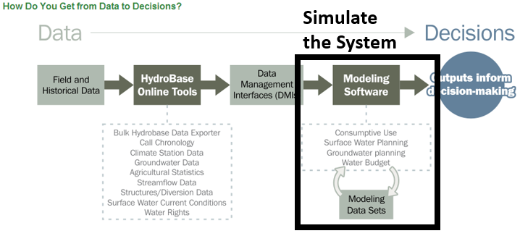

xxx

# Visualizing Point Flow Analysis Results

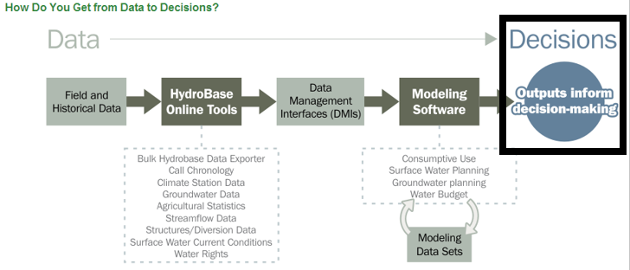

xxx

# Point Flow Analysis Potential Issues

After reading this CDSS Quick Start guide you should have a high-level understanding of what is provided by CDSS and where to find more information

# Next Steps

After reading this CDSS Quick Start guide you should have a high-level understanding of what is provided by CDSS and where to find more information. Additional Quick Start documents have been prepared or are envisioned to provide more specific introductory information. See the Open Water Foundation website ([www.openwaterfoundation.org](http://www.openwaterfoundation.org)) information for users.

* TSTool Quick Start
* Point Flow Analysis Quick Start (envisioned)
* StateDMI Quick Start (envisioned)
* StateMod Quick Start (envisioned)
* StateCU Quick Start (envisioned)

# Resources

* CDSS website: cdss.state.co.us
* CWCB website: cwcb.state.co.us
* DWR website: water.state.co.us