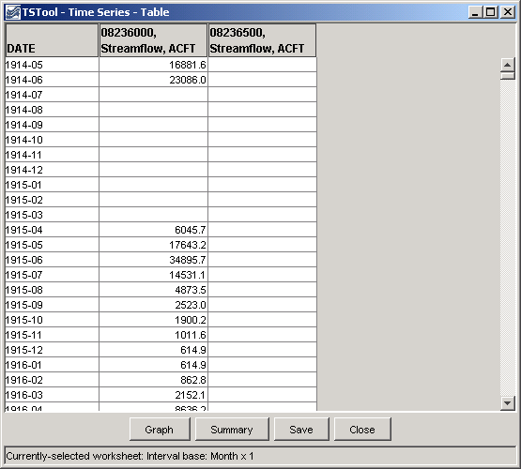TSTool – Time Series Tool

**User Manual**

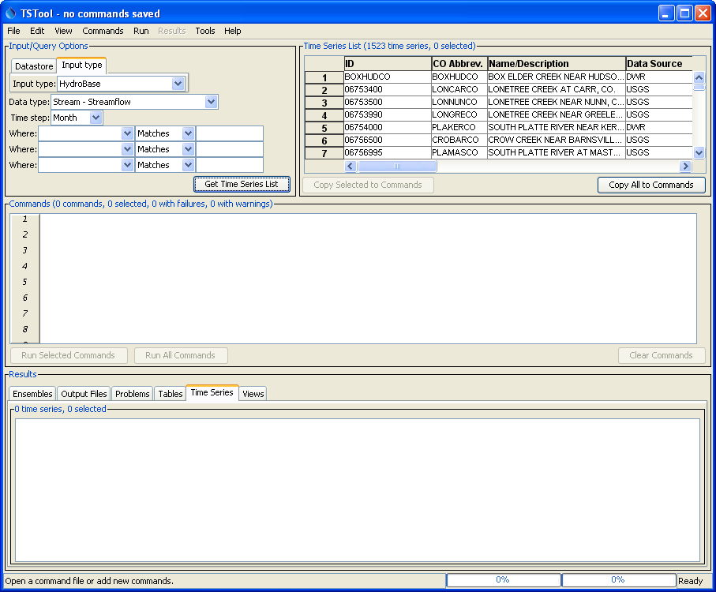

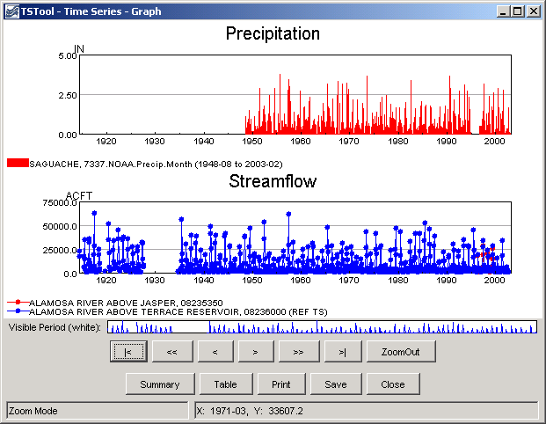

Colorado Department of Natural Resources

Colorado Water Conservation Board

Division of Water Resources

*Developed by:*



**Version 11.07.05, 2015-12-09**

This page is intentionally blank.

This document is formatted for double-sided printing.