Command Reference: Empty Line

Empty line

Version 11.03.01, 2015-06-05

The empty line command is a place-holder for empty lines in command files, needed to avoid the line being treated as an unknown command.

The following dialog is used to edit the command and illustrates the command syntax:

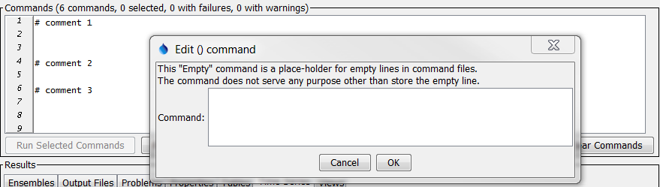

Empty

Command Editor for an Empty Line

This page is intentionally blank.