Command Reference: #

Comment line

Version 11.03.00, 2015-05-31

The # command indicates single-line comments. Commands can be converted to and from # comments by right-clicking on a command in TSTool and selecting from the popup menu. See also the /* and */ comment block commands, which are used to comment multiple commands.

The following table lists annotation tags that can be placed in comments to provide additional information to software that processes the commands, using notation similar to the following:

#@expectedStatus Failure

Command # Comment Tags

|  |  |  |
| --- | --- | --- |
| Annotation Tag | Command that Uses | Description |
| @enabled False | TSTool command processor | Used to disable a command file. For example, use this annotation in a test command file when the test is not ready for use in the software release process. |
| @expectedStatus Failure  @expectedStatus Warning | RunCommands() | Used to help the test framework know if an error or warning is expected, in which case a passing test can occur even if the command status is not “success”. |
| @os Windows  @os UNIX | Create  RegressionTest  CommandFile() | Used to filter out test command files that are not appropriate for the operating system. Linux is included in UNIX. |
| @readOnly | TSTool main interface and command editors | Indicates that the command file should not be edited. TSTool will update old command syntax to current syntax when a command file is loaded. However, this tag will cause the software to warn the user when saving the command file, so that they can cancel. This tag is often used with templates to protect the template from mistakenly being edited and saved in TSTool (TSTool does not currently allow editing templates within the interface). |
| @template | TSTool main interface | Similar to @readOnly and indicates a template command file. Currently, a text file editor needs to be used to edit template files because TSTool checks commands for final syntax. |
| @testSuite ABC | Create  RegressionTest  CommandFile() | Used to filter out test command files that are not appropriate for the operating system. |

The following dialog is used to edit the command and illustrates the command syntax:

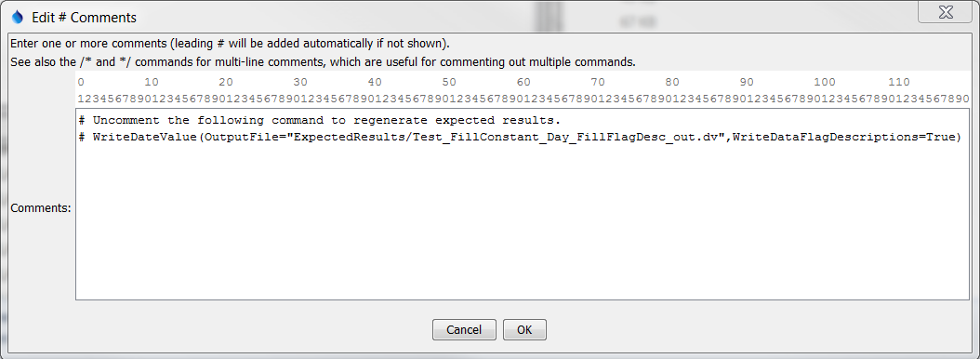

Comment

# Command Editor

The command syntax is as follows:

# Some text

A sample command file is as follows:

|  |
| --- |
| #  # Some comments…  # |