Command Reference: Time Series Identifier (TSID)

Read a single time series given the time series identifier

Version 11.09.02, 2016-03-07

A time series identifier (TSID) command reads a single time series. This is one of the few TSTool commands that does not follow the Command(ParameterName=ParameterValue,…) syntax. See also the ReadTimeSeries() command, which provides parameters to control the read, and the ReadTimeSeriesList() command, which read multiple time series given a list of time series in a table. In order to read the time series from a persistent format (database, file, or web site), the TSID must contain the datastore name (or input type), and if necessary, the input name. For example, a TSID command for the State of Colorado’s StateMod model file format is of the form:

LocationID…Month~StateMod~Filename

Refer to the documentation for the datastore or input type to understand the format of the TSID. The TSTool main interface can be used to interactively format TSIDs in many cases.

The following dialog is used to edit the command and illustrates the syntax of the command. Limited checks are done while editing the command (e.g., verify that a valid data interval is used). Once the command is saved, TSTool will attempt to read the time series metadata and will issue a warning if unable to read the data. Time series identifiers that include filenames should typically be adjusted to a relative path to allow the files to be moved to another location and run without errors.

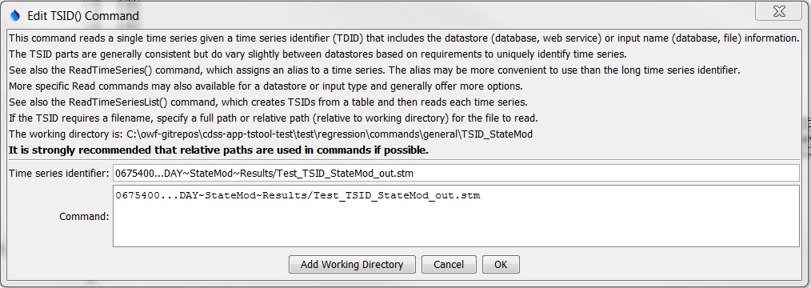

TSID_StateMod

TSID Command Editor for a Time Series Read From a StateMod File

The following example is for a TSID for the State of Colorado’s HydroBase database. In this case the datastore name is specified at the end of the TSID.

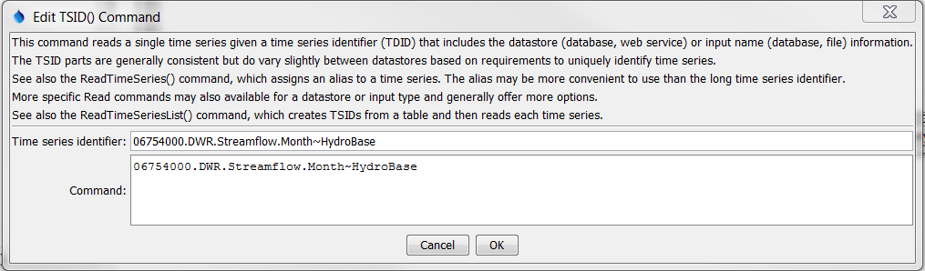

TSID

TSID Command Editor for a Time Series Read From the HydroBase Database

After executing the command, the time series will have the identifier as originally requested, with no alias being assigned. Use ReadTimeSeries() command to assign an alias to the time series, or use one of the specific read commands.

A sample command file to read time series from a StateMod file is as follows. In this case the absolute paths have been adjusted to relative paths using the command editor dialog. Note also that the data source and data type are not required in this example because this information is not stored in the StateMod file.

|  |
| --- |
| 09303000...MONTH~StateMod~whiteT.rih  09303400...MONTH~StateMod~whiteT.rih |

A sample command file to read time series from the State of Colorado’s HydroBase database is as follows:

|  |
| --- |
| # 06754000 - SOUTH PLATTE RIVER NEAR KERSEY  06754000.DWR.Streamflow.Month~HydroBase  # 06758500 - SOUTH PLATTE RIVER NEAR WELDONA  06758500.DWR.Streamflow.Month~HydroBase |