Command Reference: Add()

Add one or more time series to a time series (or ensemble)

Version 11.12.00, 2016-07-14

The Add() command adds regular interval time series. The receiving time series will be set to the sum of itself and all indicated time series. See also the NewTimeSeries() command, which can create an empty time series to receive a sum. If an ensemble is being processed, another ensemble can be added, a single time series can be added to all time series in the ensemble, or a list of time series can be added to the ensemble (the number in the list must match the number of time series in the ensemble).

This command will generate an error if the time series do not have compatible units. If the units are compatible but are not the same (e.g., IN and FT), then the units of the part will be converted to the units of the sum before addition. Missing data in the parts can be ignored (do not set the sum to missing) or can result in missing values in the sum. Implications of ignoring missing data should be considered. Time series being added must have the same data interval.

The following dialog is used to edit the command and illustrates the syntax of the command.

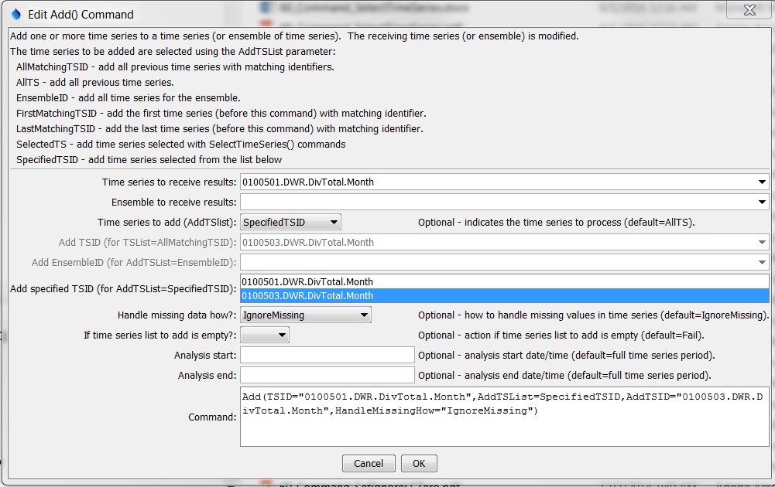

Add

Add() Command Editor

The command syntax is as follows:

Add(Parameter=Value,…)

Command Parameters

|  |  |  |
| --- | --- | --- |
| Parameter | Description | Default |
| TSID | The time series identifier or alias for the time series to receive the sum. Can be specified using processor ${Property}. | TSID or EnsembleID must be specified. |
| EnsembleID | The ensemble to receive the sum, if processing an ensemble. Can be specified using processor ${Property}. | TSID or EnsembleID must be specified. |
| AddTSList | Indicates how the list of time series is specified, one of:   * AllTS – all time series before the command. * AllMatchingTSID – all time series that match the AddTSID (single TSID or TSID with wildcards) will be added. * EnsembleID – the time series from ensemble will be added. * LastMatchingTSID – the last time series that matches the TSID (single TSID or TSID with wildcards) will be added. * SelectedTS – the time series are those selected with the SelectTimeSeries() command. * SpecifiedTSID – the specified list of time series given by the AddTSID parameter. | AllTS (the time series receiving the sum will not be added to itself) |
| AddTSID | If the AddTSList parameter is SpecifiedTSID, provide the list of time series identifiers (or alias) to add, separated by commas. If the AddTSList parameter is AllMatchingTSID, FirstMatchingTSID, or LastMatchingTSID, specify a single TSID or a TSID with wildcards. Can be specified using processor ${Property}. | Must be specified if TSList=  SpecifiedTSID, ignored otherwise. |
| AddEnsembleID | If the EnsembleID parameter is specified, providing an ensemble ID will add the ensembles. Can be specified using processor ${Property}. | Use if an ensemble is being added to another ensemble. |
| Handle  MissingHow | Indicates how to handle missing data in a time series, one of:   * IgnoreMissing – create a result even if missing data are encountered in one or more time series – this option is not as rigorous as the others * SetMissingIfOtherMissing – set the result missing if any of the other time series values is missing * SetMissingIfAnyMissing – set the result missing if any time series value involved is missing | IgnoreMissing |
| IfTSListToAdd  IsEmpty | Action if time series list to add is empty. | Fail |
| AnalysisStart | The date/time to start analyzing data. Can be specified using processor ${Property}. | Full period is analyzed. |
| AnalysisEnd | The date/time to end analyzing data. Can be specified using processor ${Property}. | Full period is analyzed. |

A sample command file to add two time series from the State of Colorado’s HydroBase is as follows:

|  |
| --- |
| # 0100501 - EMPIRE DITCH  0100501.DWR.DivTotal.Month~HydroBase  # 0100503 - RIVERSIDE CANAL  0100503.DWR.DivTotal.Month~HydroBase  Add(TSID="0100501.DWR.DivTotal.Month",TSList="SpecifiedTSID",  AddTSID="0100503.DWR.DivTotal.Month",HandleMissingHow=IgnoreMissing) |

This page is intentionally blank.