Command Reference: AddConstant()

Add a constant value to all data values in a time series (or ensemble)

Version 11.10.00, 2016-04-11

The AddConstant() command adds a constant value to each data value in a time series (or ensemble of time series) within the specified period. This command is useful, for example, when a time series needs to be adjusted for a constant bias. Another example is to adjust a reservoir total volume time series by the dead pool storage in order to compute the active storage (or inverse). Missing data values will remain missing in the result.

The following dialog is used to edit the command and illustrates the syntax of the command.

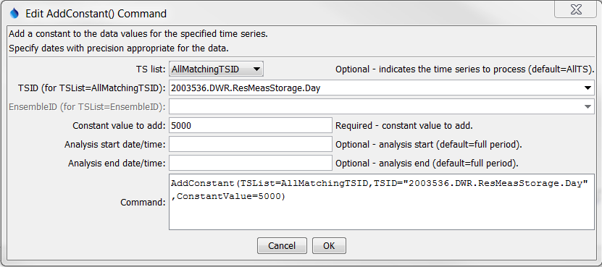

AddConstant

AddConstant() Command Editor

The command syntax is as follows:

AddConstant(Parameter=Value,…)

Command Parameters

|  |  |  |
| --- | --- | --- |
| Parameter | Description | Default |
| TSList | Indicates the list of time series to be processed, one of:   * AllMatchingTSID – all time series that match the TSID (single TSID or TSID with wildcards) will be modified. * AllTS – all time series before the command. * EnsembleID – all time series in the ensemble will be modified. * LastMatchingTSID – the last time series that matches the TSID (single TSID or TSID with wildcards) will be modified. * SelectedTS – the time series are those selected with the SelectTimeSeries() command. | AllTS |
| TSID | The time series identifier or alias for the time series to be modified. Can be specified using processor ${Property}. | TSID or EnsembleID must be specified. |
| EnsembleID | The ensemble to be modified, if processing an ensemble. Can be specified using processor ${Property}. | TSID or EnsembleID must be specified. |
| ConstantValue | The data value to add to the time series. Can be specified using processor ${Property}. | None – must be specified. |
| AnalysisStart | The date/time to start analyzing data. Can be specified using processor ${Property}. | Full period. |
| AnalysisEnd | The date/time to end analyzing data. Can be specified using processor ${Property}. | Full period. |

A sample commands file to process data from the State of Colorado’s HydroBase is as follows:

|  |
| --- |
| # 2003536 - CONTINENTAL RES  2003536.DWR.ResMeasStorage.Day~HydroBase  AddConstant(TSList=AllMatchingTSID,TSID="2003536.DWR.ResMeasStorage.Day",  ConstantValue=5000) |

CommandReference/AddConstant/Example_AddConstant_HydroBase.TSTool