Command Reference: AppendTable()

Append one table to another table

Version 11.04.00, 2015-07-011

The AppendTable() command appends rows from one table to another table, resulting in more rows being added to the first table. This command does not “join” tables horizontally (for such functionality see the JoinTables() command). For appended rows:

* values in columns that are not matched are set to null in the receiving table
* values in columns where the data types do not match are set to null in the receiving table

The following dialog is used to edit the command and illustrates the syntax of the command.

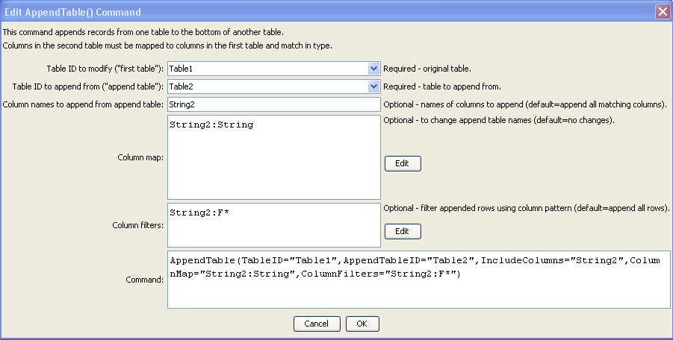

AppendTable

AppendTable() Command Editor

The command syntax is as follows:

AppendTable(Parameter=Value,…)

Command Parameters

| Parameter | Description | Default |
| --- | --- | --- |
| TableID | The identifier for the original table, to which records will be appended. Can be specified using processor ${Property}. | None – must be specified. |
| Append  TableID | The identifier for the table from which to append. Can be specified using processor ${Property}. | None – must be specified. |
| Include  Columns | The names of columns to append from AppendTableID, separated by commas. See also ColumnMap to indicate how to map column names in the append table to the first table (necessary if the column names don’t match). | Append all of the columns from AppendTableID that match columns in TableID. |
| ColumnMap | The map of the append table columns to the first table’s columns, necessary when column names are not the same:  AppendColumn1:OriginalColumn1, AppendColumn2:OriginalColumn2 | If no map, append table column names in IncludeColumns must have the same name in the first table. |
| Column  Filters | Filters that limit the number of rows being appended from the append table, using the syntax:  AppendColumn1:FilterPattern1, AppendColumn2:FilterPattern2  Patterns can use \* to indicate wildcards for matches. Only string values can be checked (other data types are converted to strings for comparison). Comparisons are case-independent. All patterns must be matched in order to append the row. In the future a command may be added to perform queries on tables, similar to SQL for databases. | No filtering. |

The following figures show the input tables and results (modified first table) corresponding to the parameters shown in the editor dialog figure above. Note that the column names for “Table2” have a “2”.

|  |  |
| --- | --- |
| command_AppendTable_Table1  AppendTable\_Table1  Table Corresponding to TableID in Command Editor | command_AppendTable_Table2  AppendTable\_Table2  Table Corresponding to AppendTableID in Command Editor |

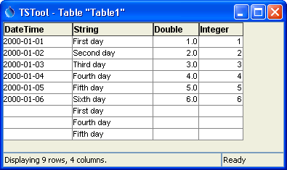

AppendTable\_Table1

Table Corresponding to Results from Parameters in Command Editor