Command Reference: CalculateTimeSeriesStatistic()

Calculate time series statistic

Version 11.02.00, 2015-05-18

The CalculateTimeSeriesStatistic() command calculates a statistic for a time series (typically a single value, but may have multiple output values) and optionally adds the result to a table and/or sets a time series property. Multiple time series can be processed. The sample from each time series consists of data values for the full period or a shorter analysis period if specified for the command. Missing values typically are ignored unless significant for the statistic (e.g., Statistic=MissingCount).

The following dialog is used to edit the command and illustrates the command syntax. Most statistics do not require additional input; however, those that do utilize the Value* parameters to specify additional information. See the documentation below and move the mouse over the entry fields in the dialog.

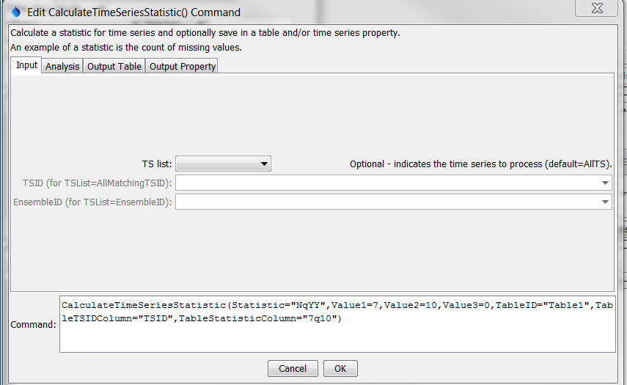

CalculateTimeSeriesStatiistic

CalculateTimeSeriesStatistic() Command Editor Showing Input Parameters

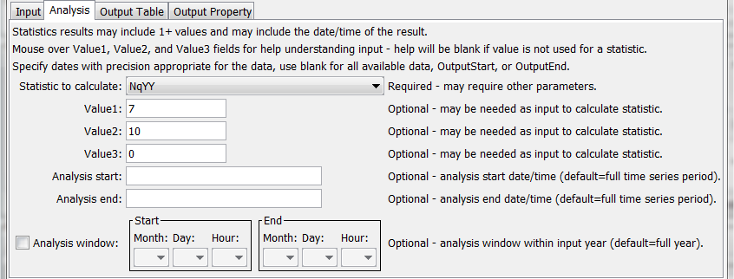

CalculateTimeSeriesStatiistic_Analysis

CalculateTimeSeriesStatistic() Command Editor Showing Analysis Parameters

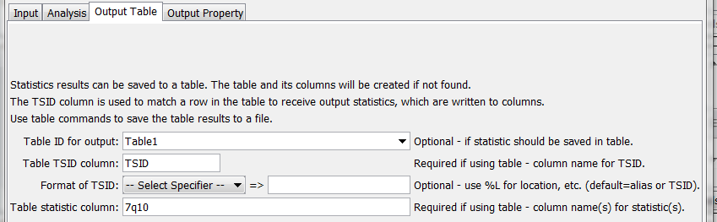

CalculateTimeSeriesStatiistic_OutputTable

CalculateTimeSeriesStatistic() Command Editor Showing Output Table Parameters

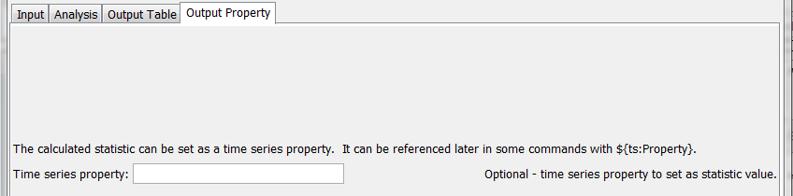

CalculateTimeSeriesStatiistic_OutputProperty

CalculateTimeSeriesStatistic() Command Editor Showing Output Property Parameters

The command syntax is as follows:

CalculateTimeSeriesStatistic(Parameter=Value,…)

Command Parameters

| Parameter | Description | Default |
| --- | --- | --- |
| TSList | Indicates the list of time series to be processed, one of:   * AllMatchingTSID – all time series that match the TSID (single TSID or TSID with wildcards). * AllTS – all time series before the command. * EnsembleID – all time series in the ensemble. * FirstMatchingTSID – the first time series that matches the TSID (single TSID or TSID with wildcards). * LastMatchingTSID – the last time series that matches the TSID (single TSID or TSID with wildcards). * SelectedTS – the time series selected with the SelectTimeSeries() command. | AllTS |
| TSID | The time series identifier or alias for the time series to be processed, using the * wildcard character to match multiple time series. | Required if TSList=*TSID. |
| EnsembleID | The ensemble to be processed, if processing an ensemble. | Required if TSList=EnsembleID. |
| Statistic | Statistic to compute as shown in the Statistic Details table below. | None – must be specified. |
| Value1 | Input data required by the statistic. Currently the dialog does not check the value for correctness – it is checked when the statistic is computed. | See Statistic Details table below. |
| Value2 | Input data required by the statistic. Currently the dialog does not check the value for correctness – it is checked when the statistic is computed. | See Statistic Details table below. |
| Value3 | Input data required by the statistic. Currently the dialog does not check the value for correctness – it is checked when the statistic is computed. | See Statistic Details table below. |
| AnalysisStart | The date/time to start analyzing data as valid date/time string or ${Property}. | Full period is analyzed. |
| AnalysisEnd | The date/time to end analyzing data as valid date/time string or ${Property}. | Full period is analyzed. |
| Analysis  WindowStart | The calendar date/time for the analysis start within each year. Specify using the format MM, MM-DD, MM-DD hh, or MM-DD hh:mm, consistent with the time series interval precision. A year of 2000 will be used internally to parse the date/time. Use this parameter to limit data processing within the year, for example to analyze only a season. The analysis window has only been enabled for Count, GECount, GTCount, LECount, LTCount, Max, Min, MissingCount, MissingPercent, NonmissingCount, and NonmissingPercent statistics. | Analyze the full year. |
| Analysis  WindowEnd | Specify date/time for the analysis end within each year. See AnalysisWindowStart for details. | Analyze the full year. |
| TableID | Identifier for table that receives the statistic. An existing table can be specified. If not found, a new table will be created. | Optional – table output is not required. |
| TableTSIDColumn | Table column name that is used to look up the time series. If a matching TSID is not found, a row will be added to the table. If a TSID is found, the statistic cell value for the time series is modified. The column name can use time series % specifiers (e.g., %L for location) and properties using syntax ${ts:Property}. | Optional – table output is not required. |
| TableTSIDFormat | The specification to format the time series identifier to insert into the TSID column. Use the format choices and other characters to define a unique identifier. | Time series alias if available, or the time series identifier. |
| TableStatistic Column | Table column name(s) to receive the statistic value(s). If not found in the table, a new column is added automatically. The column names can use time series % specifiers (e.g., %L for location) and properties using syntax ${ts:Property}. | Optional – table output is not required. |
| TimeSeries  PropertyName | If specified, the output statistic will be set as a property value for the time series. In the future, statistics with multiple values will use a variation of the property name. | No property is set. |

The following table provides additional information about specific statistics, in particular to describe how the statistic is computed, whether additional input needs to be provided with Value command parameters, and whether multiple statistic values are output in results.

Statistic Details

| Statistic | Description | Required Values |
| --- | --- | --- |
| Count | Number of data values total, including missing and non-missing. |  |
| DeficitMax | Maximum deficit value (where deficit is mean minus value). |  |
| DeficitMean | Mean deficit value (where deficit is mean minus value). |  |
| DeficitMin | Minimum deficit value (where deficit is mean minus value). |  |
| DeficitSeqLengthMax | Maximum number of sequential intervals where each value is less than the mean (for example maximum drought length). |  |
| DeficitSeqLengthMean | Mean number of sequential intervals where each value is less than the mean (for example mean drought length). |  |
| DeficitSeqLengthMin | Minimum number of sequential intervals where each value is less than the mean (for example minimum drought length). |  |
| DeficitSeqMin | Maximum sum of sequential values where each value is less than the mean (for example maximum drought water volume). |  |
| DeficitSeqMean | Mean of the sum of sequential values where each value is less than the mean (for example mean drought water volume). |  |
| DeficitSeqMin | Minimum sum of sequential values where each value is less than the mean (for example minimum drought water volume). |  |
| GECount | Count of values greater than or equal to Value1. | Value1 – criteria to check |
| GTCount | Count of values greater than Value1. | Value1 – criteria to check |
| Lag-1AutoCorrelation | Autocorrelation between values and the those that follow in the next time step, given by:  *rk = Σi=1N-k(Yi - Ymean)(Yi + k - Ymean)*  *Σi=1N(Yi - Ymean)2* |  |
| Last | Last non-missing value. Second statistic is the date/time of the value. |  |
| LECount | Count of values less than or equal to Value1. | Value1 – criteria to check |
| LTCount | Count of values less than Value1. | Value1 – criteria to check |
| Max | Maximum value. |  |
| Mean | Mean value. |  |
| Min | Minimum value. |  |
| MissingCount | Number of missing values. |  |
| MissingPercent | Percent of values that are missing. |  |
| MissingSeqLengthMax | Maximum number of sequential values that are missing. |  |
| NonmissingCount | Number of non-missing values. |  |
| NonmissingPercent | Percent of values that are not missing. |  |
| NqYY | This statistic is typically used to evaluate the return period of low flows and is implemented only for daily data. The N indicates the number of daily values to be averaged and YY indicates the return interval. For example, 7q10 indicates the flow corresponding to the 10-year recurrence interval for minimum average daily flow (for 7 days) in a year. This statistic is computed as follows, using 7q10 as an example:   1. Determine the number of years to be analyzed (from analysis period command parameters or time series data). 2. For each year, loop through each day from January 1 to December 31. Compute an average flow by averaging 7 days, in this case with 3 values on each side of the current day and including the current day. If at the end of the year, use 3 values from adjoining years. The number of missing data allowed is controlled by the Value3 command parameter. 3. For the year, save the minimum 7-day average. 4. Utilize the minimum values for all years, with log-Pearson Type III distribution, to determine the value for the 10-year recurrence interval. See <http://pubs.usgs.gov/sir/2008/5126/section3.html> for a description of NqYY and “Hydrology for Engineers, 3rd Edition,” Linsley, Kohler, Paulhus for a description of log-Pearson Type III distribution. | Value1 – specify the number of daily values to be averaged. Currently this must be an odd number to allow bracketing the current day.  Value2 – specify the return interval (e.g., 10).  Value3 – specify the number of missing values allowed in the average (e.g., 0 for most rigorous analysis). It may be useful to set this value if, for example, a single daily value is available in the time series, for example entered on the first day of the month. |
| Skew | Skew coefficient, as follows:  *Cs = N Σi=1N(Yi - Ymean)3*  *(n – 1)(n – 2)s3*  where *s* = standard deviation |  |
| StdDev | Standard deviation. |  |
| SurplusMin | Maximum surplus value (where surplus is value minus mean). |  |
| SurplusMean | Mean surplus value (where surplus is value minus mean). |  |
| SurplusMin | Minimum surplus value (where surplus is value minus mean). |  |
| SurplusSeqLengthMax | Maximum number of sequential intervals where each value is greater than the mean (for example maximum water surplus length). |  |
| SurplusSeqLengthMean | Mean number of sequential intervals where each value is greater than the mean (for example mean water surplus length). |  |
| SurplusSeqLengthMin | Minimum number of sequential intervals where each value is greater than the mean (for example minimum water surplus length). |  |
| SurplusSeqMin | Maximum sum of sequential values where each value is greater than the mean (for example maximum water surplus volume). |  |
| SurplusSeqMean | Mean of the sum of sequential values where each value is greater than the mean (for example mean water surplus volume). |  |
| SurplusSeqMin | Minimum sum of sequential values where each value is greater than the mean (for example minimum water surplus volume). |  |
| Total | Total of values. |  |
| TrendOLS | Ordinary least squares analysis is used to compute results that are named TableStatisticColumn with appended _Intercept, _Slope, and _R2. |  |
| Variance | Variance. |  |

The following example illustrates how to use the command to compute the 7q10 statistic for daily flow:

|  |
| --- |
| ReadDateValue(Alias=”linsley”,InputFile="Data\linsley.dv")  NewTable(TableID="Table1",Columns="TSID,string;7q10,double")  CalculateTimeSeriesStatistic(Statistic="NqYY",Value1=7,Value2=10,Value3=6,  TableID="Table1",TableTSIDColumn="TSID",TableStatisticColumn="7q10")  WriteTableToDelimitedFile(TableID="Table1",  OutputFile="Results/Test_CalculateTimeSeriesStatistic_7q10_linsley_out.csv") |

This page is intentionally blank.