Command Reference: ChangePeriod()

Change period of record for time series

Version 11.06.00, 2015-07-26

The ChangePeriod() command changes the period for the given time series, for example to extend the time series. A longer period will be filled with missing values.

The following dialog is used to edit the command and illustrates the syntax of the command.

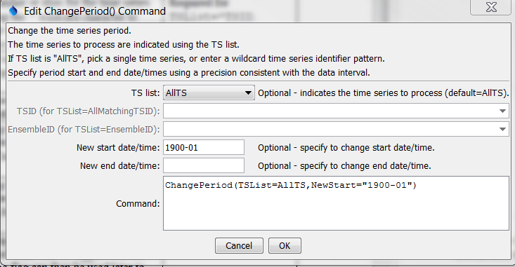

ChangePeriod

ChangePeriod() Command Editor

The command syntax is as follows:

ChangePeriod(Parameter=Value,…)

Command Parameters

|  |  |  |
| --- | --- | --- |
| Parameter | Description | Default |
| TSList | Indicates the list of time series to be processed, one of:   * AllMatchingTSID – all time series that match the TSID (single TSID or TSID with wildcards) will be modified. * AllTS – all time series before the command. * EnsembleID – all time series in the ensemble will be modified. * FirstMatchingTSID – the first time series that matches the TSID (single TSID or TSID with wildcards) will be modified. * LastMatchingTSID – the last time series that matches the TSID (single TSID or TSID with wildcards) will be modified. * SelectedTS – the time series are those selected with the SelectTimeSeries() command. | AllTS |
| TSID | The time series identifier or alias for the time series to be modified, using the * wildcard character to match multiple time series. Can be specified with a processor ${Property}. | Required if TSList=*TSID. |
| EnsembleID | The ensemble to be modified, if processing an ensemble. Can be specified with a processor ${Property}. | Required if TSList=EnsembleID. |
| NewStart | The new period start, specified to precision that matches the time series data interval. Can be specified with a processor ${Property}. | Start will remain the same. |
| NewEnd | The new period end, specified to precision that matches the time series data interval. Can be specified with a processor ${Property}. | End will remain the same. |

A sample command file to change the period of a time series from the State of Colorado’s HydroBase is as follows:

|  |
| --- |
| # 08236000 - ALAMOSA RIVER ABOVE TERRACE RESERVOIR  08236000.DWR.Streamflow.Month~HydroBase  ChangePeriod(TSList=AllTS,NewStart="1900-01") |