Command Reference: CheckTimeSeries()

Check time series data values against criteria and optionally take action

Version 11.03.01, 2015-06-06

The CheckTimeSeries() command checks time series data values against criteria, for example to identify missing, erroneous, or extreme data values. A warning is generated for each match and time series values optionally can be flagged, which allows annotation on graphs and reports. Values that meet the check criteria also can be removed (if irregular interval), or set to missing. Check results can be saved to an output table for output and further processing. The WriteCheckFile() command also can be used to write a summary of the warnings based on command messages. The CheckTimeSeriesStatistic() command checks a statistic for the entire time series (e.g., missing value count). See also the Delta() command, which creates new time series as the change between each value – this command may be necessary in cases where data periodically reset to a starting value, prior to performing a Change> check, for example.

The following dialog is used to edit the command and illustrates the command syntax.

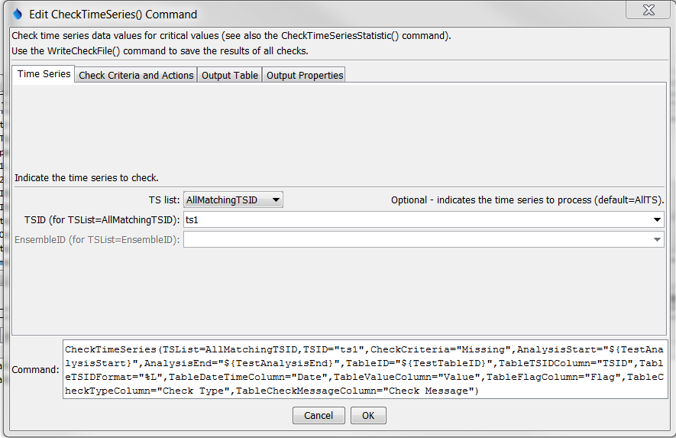

CheckTimeSeries

CheckTimeSeries() Command Editor Showing Time Series Parameters

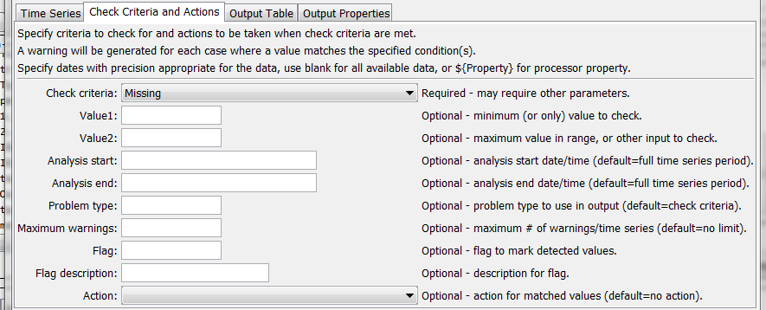

CheckTimeSeries_Criteria

CheckTimeSeries() Command Editor Showing Check Criteria and Action Parameters

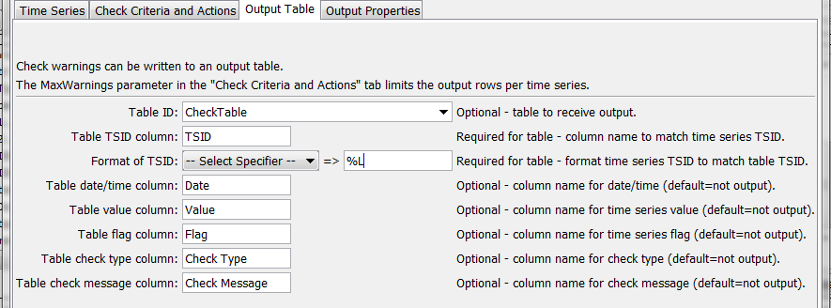

CheckTimeSeries_Table

CheckTimeSeries() Command Editor Showing Output Table Parameters

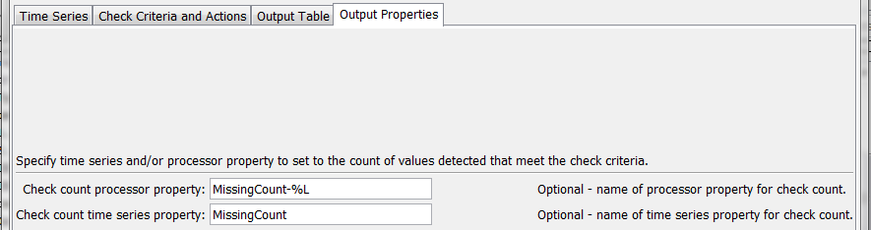

CheckTimeSeries_Properties

CheckTimeSeries() Command Editor Showing Output Properties Parameters

The command syntax is as follows:

CheckTimeSeries(Parameter=Value,…)

Command Parameters

| Parameter | Description | Default |
| --- | --- | --- |
| TSList | Indicates the list of time series to be processed, one of:   * AllMatchingTSID – all time series that match the TSID (single TSID or TSID with wildcards) will be processed. * AllTS – all time series before the command will be processed. * EnsembleID – all time series in the ensemble will be processed. * FirstMatchingTSID – the first time series that matches the TSID (single TSID or TSID with wildcards) will be processed. * LastMatchingTSID – the last time series that matches the TSID (single TSID or TSID with wildcards) will be processed. * SelectedTS – the time series selected with the SelectTimeSeries() command will be processed. | AllTS |
| TSID | The time series identifier or alias for the time series to be processed, using the * wildcard character to match multiple time series. Can be specified using processor ${Property}. | Required if TSList=*TSID. |
| EnsembleID | The ensemble to be modified, if processing an ensemble. Can be specified using processor ${Property}. | Required if TSList= EnsembleID. |
| CheckCriteria | The criteria that is checked, one of the following. Missing values are skipped except for cases where the statistic is specific to missing values.   * AbsChange> – check for absolute change from one value to the next value > Value1 * AbsChangePercent> – check for absolute change in percent from one value to the next value > Value1. * Change> – check for change > Value1. * Change< – check for change < Value1. * InRange – check for value >= Value1 and <= Value2. * OutOfRange – check for value < Value1 or > Value2. * Missing – check for missing values. * Repeat – check for Value1 repeating values (i.e., if Value1=2, then the check will detect 2 adjacent values that are the same). If the flag or action are specified, values Value1+ in the sequence are modified (i.e., if Value1=2, the 2nd and subsequent repeating values will be modified by the action). * < – check for values < Value1. * <= – check for values <= Value1. * > – check for values > Value1. * >= – check for values >= Value1. * == – check for values equal to Value1. | None – must be specified. |
| Value1 | A parameter that is used for specific CheckCriteria values. |  |
| Value2 | A parameter that is used for specific CheckCriteria values. |  |
| AnalysisStart | The date/time to start analyzing data. Can be specified using processor ${Property}. | Analyze full period. |
| AnalysisEnd | The date/time to end analyzing data. Can be specified using processor ${Property}. | Analyze full period. |
| ProblemType | The problem type that will be shown in warning messages. | CheckCriteria |
| MaxWarnings | The maximum number of warnings to list for each time series, useful if analysis results in many warnings. | List all warnings. |
| Flag | A string to use for a flag on values that are detected during the check, which will be shown in the HTML summary report. | No flag. |
| FlagDesc | Description for the flag. | No description. |
| Action | Action to take for matched values, in addition to generating warnings:   * Remove – remove the values. For irregular interval time series the values will be removed. For regular interval time series the values will be set to missing. * SetMissing – set the values to missing. | No action is taken. |
| TableID | Identifier for output table to contain check results. Specify an existing table or new table to create. Can be specified using processor ${Property}. | No table output. |
| TableTSIDColumn | Table column name for time series TSID. | Required for table. |
| TableTSIDFormat | The specification to format the time series identifier to insert into the TSID column. Use the format choices and other characters to define a unique identifier. | Required for table. |
| TableDateTime Column | Table column name for date/time. | Column is not output. |
| TableValue Column | Table column name for time series data values. | Column is not output. |
| TableFlag Column | Table column name for time series data flag values. | Column is not output. |
| TableCheckType Column | Table column name for data check type. | Column is not output. |
| TableCheck MessageColumn | Table column name for data check message. | Column is not output. |
| CheckCount  Property | Name of processor property to set with count of values that meet the criteria. Can use processor ${Property} and time series % or ${ts:Property}. | No property is set. |
| CheckCount  TimeSeries  Property | Name of time series property to set with count of values that meet the criteria. Can use processor ${Property} and time series % or ${ts:Property}. | No property is set. |

This page is intentionally blank.