Command Reference: CheckTimeSeriesStatistic()

Check time series statistic against criteria

Version 10.00.01, 2011-04-26

The CheckTimeSeriesStatistic() command checks a time series statistic against criteria, for example to perform quality control using full-period statistics. This command is essentially a combination of the CalculateTimeSeriesStatistic() command with features similar to the CheckTimeSeries() command; however, the latter checks individual data values and this command checks a statistic computed from the entire time series. The WriteCheckFile() command can be used to write a summary of the warnings.

The following dialog is used to edit the command and illustrates the command syntax, in this case to check for time series that have >= 5% missing data values.

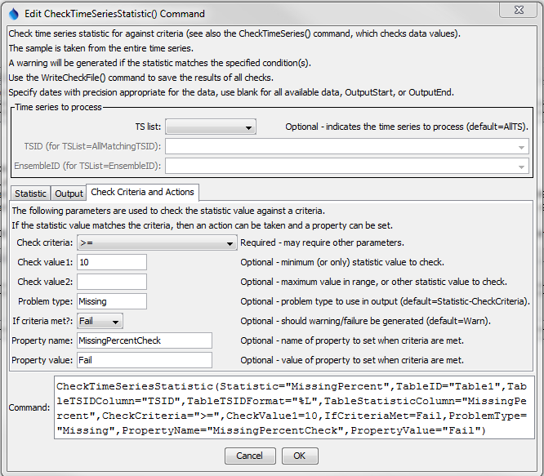

CheckTimeSeriesStatistic

CheckTimeSeriesStatistic() Command Editor for Statistic Parameters

The following parameters will output the location part of the TSID to a column named TSID and the missing percentage to a column named MissingPercent in the output table named Table1.

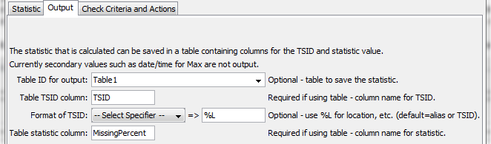

CheckTimeSeriesStatistic_Output

CheckTimeSeriesStatistic() Command Editor for Output Parameters

The percentage of missing values is then checked to see if >= 10 and if so the command will fail and the time series will have a property set MissingPercentCheck=Fail.

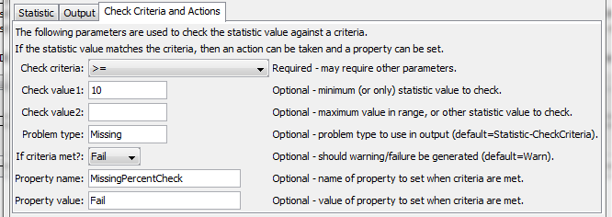

CheckTimeSeriesStatistic_Output

CheckTimeSeriesStatistic() Command Editor for Check Criteria and Action Parameters

The command syntax is as follows:

CheckTimeSeriesStatistic(Parameter=Value,…)

Command Parameters

| Parameter | Description | Default |
| --- | --- | --- |
| TSList | Indicates the list of time series to be processed, one of:   * AllMatchingTSID – all time series that match the TSID (single TSID or TSID with wildcards) will be processed. * AllTS – all time series before the command will be processed. * EnsembleID – all time series in the ensemble will be processed. * FirstMatchingTSID – the first time series that matches the TSID (single TSID or TSID with wildcards) will be processed. * LastMatchingTSID – the last time series that matches the TSID (single TSID or TSID with wildcards) will be processed. * SelectedTS – the time series selected with the SelectTimeSeries() command will be processed. | AllTS |
| TSID | The time series identifier or alias for the time series to be processed, using the * wildcard character to match multiple time series. | Required if TSList=*TSID. |
| EnsembleID | The ensemble to be modified, if processing an ensemble. | Required if TSList= EnsembleID. |
| Statistic | Statistic to compute. Refer to the CalculateTimeSeriesStatistic() command documentation. | None – must be specified. |
| StatisticValue1 | Input data required by the statistic. Currently the dialog does not check the value for correctness – it is checked when the statistic is computed. | See the Calculate TimeSeries Statistic() command documentation. |
| StatisticValue2 | Input data required by the statistic. Currently the dialog does not check the value for correctness – it is checked when the statistic is computed. | to the Calculate TimeSeries Statistic() command documentation. |
| StatisticValue3 | Input data required by the statistic. Currently the dialog does not check the value for correctness – it is checked when the statistic is computed. | to the Calculate TimeSeries Statistic() command documentation. |
| AnalysisStart | The date/time to start analyzing data. | Full period is analyzed. |
| AnalysisEnd | The date/time to end analyzing data. | Full period is analyzed. |
| TableID | Identifier for table that receives the statistic. | Optional – table output is not required. |
| TableTSIDColumn | Table column name that is used to look up the time series. If a matching TSID is not found, a row will be added to the table. If a TSID is found, the statistic cell value for the time series is modified. | Optional – table output is not required. |
| TableTSIDFormat | The specification to format the time series identifier to insert into the TSID column. Use the format choices and other characters to define a unique identifier. | Time series alias if available, or the time series identifier. |
| TableStatistic Column | Table column name to receive the statistic value. If not found in the table, a new column is added automatically. | Optional – table output is not required. |
| CheckCriteria | The criteria that is checked, one of:   * InRange – check for value >= Value1 and <= Value2. * OutOfRange – check for value < Value1 or > Value2. * < – check for values < CheckValue1. * <= – check for values <= CheckValue1. * > – check for values > CheckValue1. * >= – check for values >= CheckValue1. * == – check for values equal to CheckValue1. | None – must be specified. |
| CheckValue1 | A parameter that is used for specific CheckCriteria values. |  |
| CheckValue2 | A parameter that is used for specific CheckCriteria values, currently only needed for InRange and OutOfRange criteria. |  |
| ProblemType | The problem type that will be shown in warning messages. | Statistic-CheckCriteria |
| IfCriteriaMet | Indicate whether to set the command status if the statistic meets the criteria, one of:   * Ignore – do not set the command status * Warn – set the command status to Warning * Fail – set the command status to Failure | The command status will not be changed. |
| PropertyName | If the statistic meets the criteria, set the property identified by PropertyName to PropertyValue. | No property is set. |
| PropertyValue | If the statistic meets the criteria, set the property identified by PropertyName to PropertyValue. | No property is set. |