Command Reference: CloseDataStore()

Close a database datastore

Version 11.00.00, 2015-02-15

The CloseDataStore() command closes a datastore’s database connection. Closing the connection will cause subsequent interactions with the datastore’s database to fail. This command is used to simulate dropped database connections (for example when TSTool does not read from or write to database for a period due to user inaction). Some database datastores have been updated to auto-connect to the database when the connection is dropped.

The following dialog is used to edit the command and illustrates the syntax for the command.

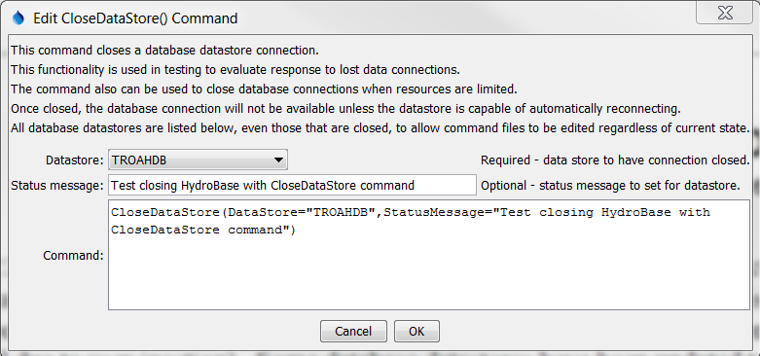

CloseDataStore

CloseDataStore() Command Editor When Querying a Single Table

The status of datastores can be shown in TSTool using the View…Datastores menu as shown in the following figure (the Status Message column on the far right, not visible in the figure, provides additional information about the datastore):

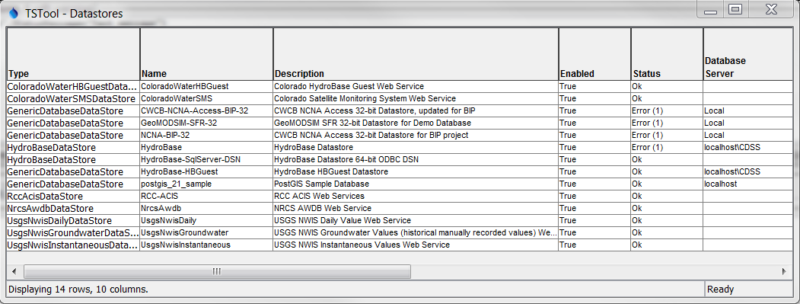

CloseDataStore_Status

Datastore Information

The command syntax is as follows:

CloseDataStore(Parameter=Value,…)

Command Parameters

|  |  |  |
| --- | --- | --- |
| Parameter | Description | Default |
| DataStore | The name of a database datastore to read. | None – must be specified. |
| StatusMessage | A status message to display when the datastore information is viewed. The status may be reset if the connection is automatically restored, for example when a subsequent database interaction occurs. | Message appropriate for closing the datastore. |