Command Reference: CloseExcelWorkbook()

Close a Microsoft Excel workbook file

Version 11.06.00, 2015-07-22

The CloseExcelWorkbook() command closes a Microsoft Excel workbook that has been opened with a previous command and kept open, for example by using the KeepOpen=True command parameter. The act of “closing” discards the workbook from program memory and optionally causes the workbook to be written to an Excel file. Using this command is helpful when multiple commands are manipulating an Excel workbook, for example when used in a For() loop block.

The following figure illustrates the dialog used to edit the command and the syntax for the command.

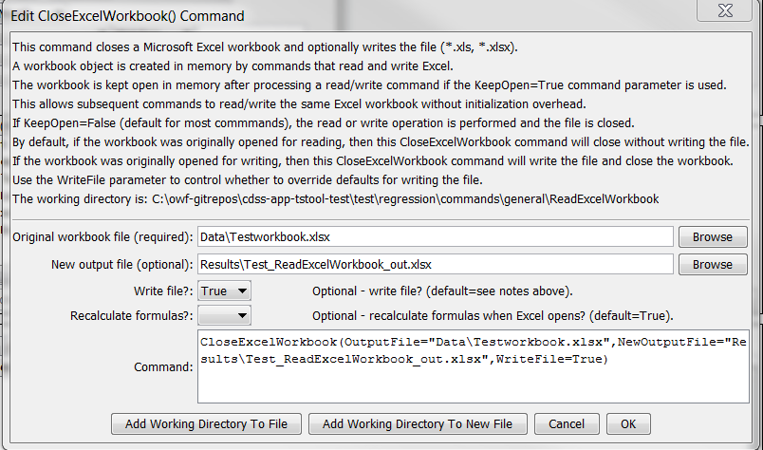

CloseExcelWorkbook

CloseExcelWorkbook() Command Editor

The command syntax is as follows:

CloseExcelWorkbook(Parameter=Value,…)

Command Parameters

| Parameter | Description | Default |
| --- | --- | --- |
| OutputFile | The name of the currently open Excel workbook (*.xls or *.xlsx) to close, as an absolute path or relative to the command file location. The filename will match that of previous commands that have read an existing or created a new Excel file. No action is performed if the open workbook is not found. Can be specified using processor ${Property}. | None – must be specified. |
| NewOutputFile | Specify if a new output file should be written. This is useful if OutputFile corresponds to an Excel file that was read but is not intended to be written over. | OutputFile |
| WriteFile | Indicate whether the output file should be written (True) or not (False). The parameter can be used to override the default behavior. | False if the workbook was originally opened for reading, True if the workbook was originally created or opened for writing. |
| Recalculate  FormulasAtOpen | The Excel file when written can be configured to cause Excel to recalculate formulas when it opens. This is the default when writing to ensure that the Excel workbook contents are up to date when opened. This parameter can be used to override the default. | True |