Command Reference: CompareTimeSeries()

Compare time series to find data value differences

Version 11.09.02, 2016-03-23

The CompareTimeSeries() command compares time series to determine data differences. Currently time series header information is NOT compared – only data values are compared. It is designed to process many time series in bulk fashion. For example, read commands can be used to read time series from two different versions of a database, or from two files. Time series to compare are determined by trying to match each available time series with another time series in the list (ignoring itself); consequently, the list of time series should contain only pairs of time series. Another option is to compare two time series directly.

Time series are compared value by value, with the differences computed as the value from the second time series minus the value from the first time series. The values can be rounded based on a specified precision. It may be important to read each set of time series from files to ensure that final round off is consistent. The checks occur by comparing the difference to one or more specified tolerances. Differences and simple statistics are printed to the log file. Values that are different can optionally be tagged with a character flag, for use with the graphing package. Time series of the differences can optionally be created. A warning can be generated if a difference is detected, or if no differences are detected (see also the CompareFiles() and CompareTables() commands).

The following dialog is used to edit the command and illustrates the syntax for the command.

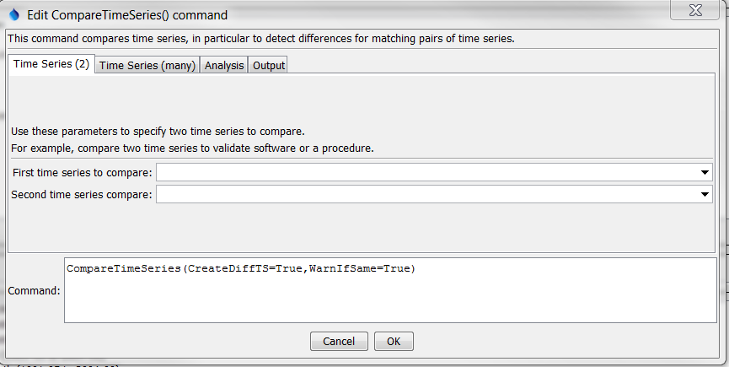

CompareTimeSeries_2

CompareTimeSeries() Command Editor Showing Parameters to Compare 2 Time Series

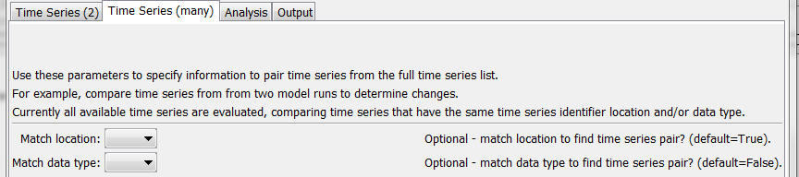

CompareTimeSeries_Many

CompareTimeSeries() Command Editor Showing Parameters to Compare Many Series

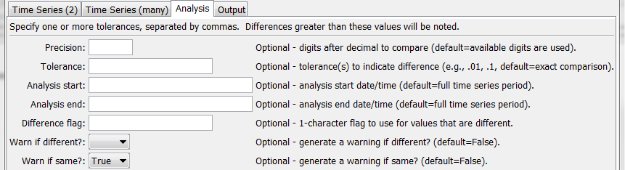

CompareTimeSeries_Analysis

CompareTimeSeries() Command Editor Showing Analysis Parameters

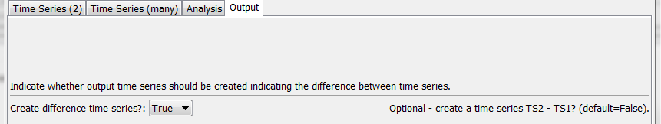

CompareTimeSeries_Output

CompareTimeSeries() Command Editor Showing Output Parameters

The command syntax is as follows:

CompareTimeSeries(Parameter=Value,…)

Command Parameters

| Parameter | Description | Default |
| --- | --- | --- |
| TSID1 | First time series identifier (or alias) to compare. | Specify if only 2 time series are compared. |
| TSID2 | Second time series identifier (or alias) to compare. | Specify if only 2 time series are compared. |
| MatchLocation | Match the location part of time series identifiers when matching time series to compare. | True |
| MatchDataType | Match the data type part of time series identifiers when matching time series to compare. | False |
| Precision | When comparing data values, round the values to the given precision. For example, a precision of 2 will round to the hundredths place. This can be used to do comparisons on the lowest precision of the available time series. | Compare the available values without rounding. |
| Tolerance | Specify a comma-separated list of values. The difference in the time series values will be compared to the tolerances and messages printed to the log file. | A tolerance of zero will be used to detect differences. |
| AnalysisStart | The starting date/time to analyze for differences. Specify a date/time of appropriate precision for the time series or OutputStart to use the output start. | Analyze all available data. |
| AnalysisEnd | The ending date/time to analyze for differences. Specify a date/time of appropriate precision for the time series or OutputEnd to use the output end. | Analyze all available data. |
| DiffFlag | Specify as a single character to append a flag to the data flags for the time series. Each value that is different is flagged in both time series that are compared. The flag can be displayed by the graphing package. This is useful for verification processes. New time series will be created with the original identifier preceded by Diff_. | Do not flag data. |
| WarnIfDifferent | If True and at least one difference is detected, a warning will be generated by the command, which will result in software like TSTool displaying a warning. If False, only status messages are written to the log file. The warning is useful if it is critical to detect any change in the time series. | Do not generate a warning if time series are different. Differences are printed to the log file. |
| WarnIfSame | If True and no differences are detected, a warning will be generated by the command, which will result in software like TSTool displaying a warning. If False, only status messages are written to the log file. The warning is useful if it is critical to detect that time series are the same. | Do not generate a warning if time series are the same. |
| CreateDiffTS | Indicate whether a time series should be created containing the differences between time series (TS2 – TS1). This is useful to visually evaluate the differences and process the results with other commands. | False |

The following example illustrates how time series from two files can be compared. For example, use similar commands to compare results from two model runs or two database queries:

|  |
| --- |
| # Example to compare files. Since they are different, a warning will be generated.  ReadDateValue(InputFile="RawData1.dv")  ReadDateValue(InputFile="RawData1Scaled.dv")  CompareTimeSeries(Precision=2,WarnIfDifferent=True) |

The following example compares matching time series for the full available period, doing checks for several tolerances:

|  |
| --- |
| CompareTimeSeries(Precision=2,Tolerance="0,.1,.5,1",DiffFlag="x") |

The following example compares data only within the output period, as specified by the SetOutputPeriod() command:

|  |
| --- |
| CompareTimeSeries(Precision=2,Tolerance="0,.1,.5,1",  AnalysisStart="OutputStart",AnalysisEnd="OutputEnd",DiffFlag="x") |