Command Reference: ConvertDataUnits()

Convert time series data units

Version 11.08.01, 2016-02-14

The ConvertDataUnits()command converts the data units for a time series (e.g., before output to a file). Some read and write commands also may allow units to be converted. See also the Scale() command, which allows units of output to be specified.

The following dialog is used to edit the command and illustrates the syntax of the command.

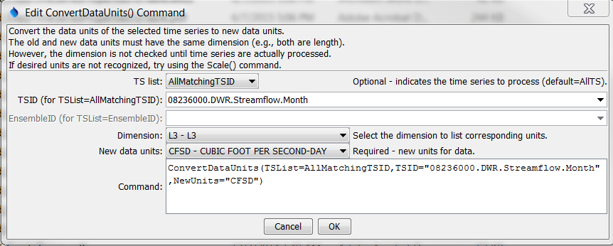

ConvertDataUnits

ConvertDataUnits() Command Editor

The Dimension choice should be selected to narrow the list of available units to the appropriate dimension. Next, select the New Data Units for the time series. The list of available data units is taken from the information described in the TSTool DATAUNIT file (see the TSTool Installation and Configuration Appendix for more information). If desired units are not available, contact the TSTool developers to suggest adding units to the DATAUNIT file or edit the command manually after initial creation. See also the TSTool View / Data Units menu to view the current data units.

The dialog cannot display the current units for the time series because the units are not available until time series are actually processed – commands are edited before processing.

The command syntax is as follows:

ConvertDataUnits(Parameter=Value,…)

Command Parameters

|  |  |  |
| --- | --- | --- |
| Parameter | Description | Default |
| TSList | Indicates the list of time series to be processed, one of:   * AllMatchingTSID – all time series that match the TSID (single TSID or TSID with wildcards) will be modified. * AllTS – all time series before the command. * EnsembleID – all time series in the ensemble will be modified. * LastMatchingTSID – the last time series that matches the TSID (single TSID or TSID with wildcards) will be modified. * SelectedTS – the time series are those selected with the SelectTimeSeries() command. | AllTS |
| TSID | The time series identifier or alias for the time series to be modified, using the * wildcard character to match multiple time series. Can be specified with ${Property} notation. | TSID or EnsembleID must be specified if identifiers are being matched. |
| EnsembleID | The ensemble to be modified, if processing an ensemble. | TSID or EnsembleID must be specified if identifiers are being matched. |
| NewUnits | The new data units. | None – must be specified. |

A sample commands file to convert the units of a time series from the State of Colorado’s HydroBase is as follows:

|  |
| --- |
| # 08236000 - ALAMOSA RIVER ABOVE TERRACE RESERVOIR  08236000.DWR.Streamflow.Month~HydroBase  ConvertDataUnits(TSList=AllMatchingTSID,  TSID="08236000.DWR.Streamflow.Month",NewUnits="CFSD") |