Command Reference: CopyFile()

Copy a file to another file

Version 10.27.00, 2014-02-18

The CopyFile() command copies one file to another file.

The following dialog is used to edit the command and illustrates the syntax for the command.

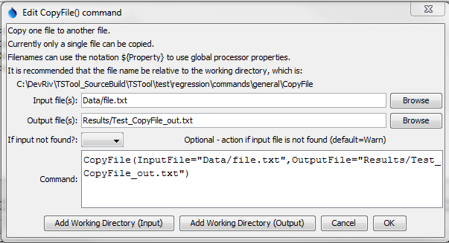

CopyFile

CopyFile() Command Editor

The command syntax is as follows:

CopyFile(Parameter=Value,…)

Command Parameters

|  |  |  |
| --- | --- | --- |
| Parameter | Description | Default |
| InputFile | The name of a file to copy. The filename may contain ${Property} notation to insert global TSTool properties in the filename. | None – must be specified. |
| OutputFile | The output file that will be created. The filename may contain ${Property} notation to insert global TSTool properties in the filename. | None – must be specified. |
| IfInputNotFound | Indicate action if the file is not found, one of:   * Ignore – ignore the missing file (do not warn). * Warn – generate a warning (use this if the file truly is expected and a missing file is a cause for concern). * Fail – generate a failure (use this if the file truly is expected and a missing file is a cause for concern). | Warn |