Command Reference: CopyTable()

Create a table as a (partial) copy of a table

Version 10.29.00, 2014-05-19

The CopyTable() command copies all or a subset of the columns from one table to create a new table. For example, this is useful to create one-column lists that can be used to expand template files with the ExpandTemplateFile() command, or to create a subset of columns to output to a file or write to a database. The following dialog is used to edit the command and illustrates the syntax of the command (in this case illustrating how values in a column named LocationID are copied to a new table).

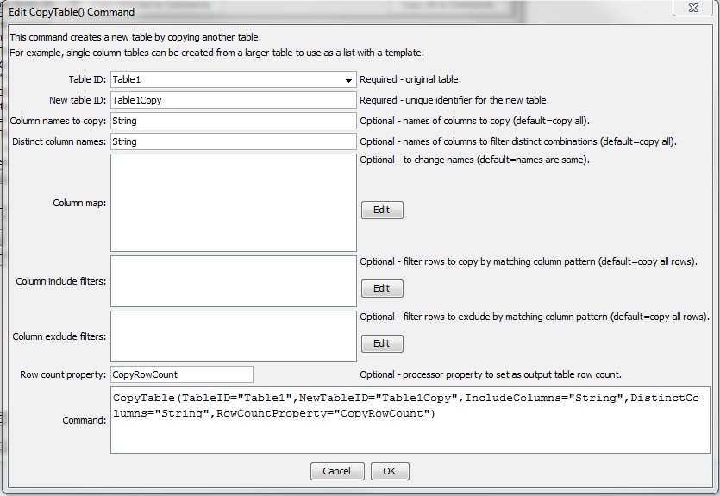

CopyTable

CopyTable() Command Editor

The command syntax is as follows:

CopyTable(Parameter=Value,…)

Command Parameters

| Parameter | Description | Default |
| --- | --- | --- |
| TableID | The identifier for the original table. | None – must be specified. |
| NewTableID | The identifier for the new table. | None – must be specified. |
| IncludeColumns | The names of columns to copy, separated by commas. | Copy all of the columns. |
| DistinctColumns | The names of columns to copy, separated by commas. Only distinct values from the specified column(s) will be copied. For example, if column A contains strings X, Y, Z, Y, C, the resulting distinct value column will have rows with X, Y, Z, C. The following behavior is implemented:   * If multiple column names are specified, the unique combination of the values will be checked. * If only the DistinctColumns are to be in the copy, specify the columns with IncludeColumns. * If columns other than DistinctColumns are in IncludeColumns, then the distinct row will be output. * Prior to TSTool 10.26.00, DistinctColumns would override IncludeColumns. * Column values null, and blank strings are not considered in distinct comparisons. | Don’t do a distinct comparison. |
| ColumnMap | The new names for the output columns, using syntax:  OriginalColumn1:NewColumn1, OriginalColumn2:NewColumn2 | The column names in the copy will be the same as in the original table. |
| ColumnFilters | Filters that limit the number of rows being copied, using the syntax:  FilterColumn1:FilterPattern1, FilterColumn2:FilterPattern2  Patterns can use * to indicate wildcards for matches. Only string values can be checked (other data types are converted to strings for comparison). Comparisons are case-independent. All patterns must be matched in order to copy the row. | No filtering. |
| ColumnExclude  Filters | Filters that exclude rows being copied, by matching column values:  ColumnExcludeFilter1:FilterPattern1,  ColumnExcludeFilter2:FilterPattern2  Patterns can use * to indicate wildcards for matches. Only string values can be checked (other data types are converted to strings for comparison). All patterns must be matched to exclude the row. |  |
| RowCount  Property | The row count for the copy will be set as a processor property. This is useful for error-checks (e.g., check that number of time series read with ReadTimeSeriesList() matches the expected count. |  |