Command Reference: CopyTimeSeriesPropertiesToTable()

Copy time series properties to a table

Version 11.03.00, 2015-06-01

The CopyTimeSeriesPropertiesToTable() command copies time series properties to a table. Properties can be copied to an existing table, or a new table can be created. Time series properties typically are set in the following ways:

1. Location and time series metadata from original data (e.g., database or web service) are set as properties when the time series are read.
2. The SetTimeSeriesProperty() command sets a property.
3. Other commands set properties as a bi-product of processing.

The following dialog is used to edit the command and illustrates the command syntax (in this case the location part of the time series identifier is used to match the contents of the “loc” column in the table).

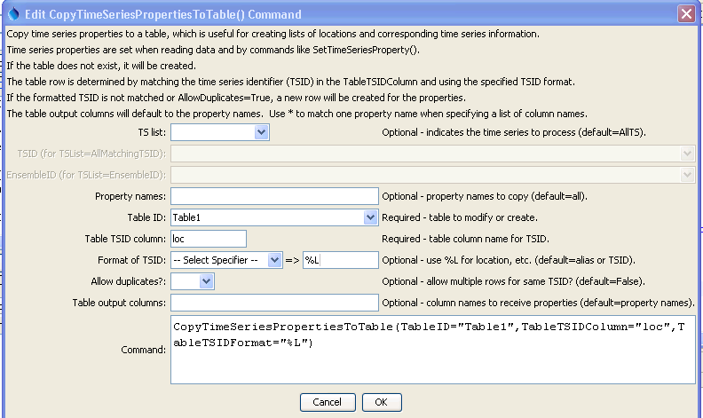

CopyTimeSeriesPropertiesToTable

CopyTimeSeriesPropertiesToTable() Command Editor

The command syntax is as follows:

CopyTimeSeriesPropertiesToTable(Parameter=Value,…)

Command Parameters

| Parameter | Description | Default |
| --- | --- | --- |
| TSList | Indicates the list of time series to be processed, one of:   * AllMatchingTSID – all time series that match the TSID (single TSID or TSID with wildcards). * AllTS – all time series before the command. * EnsembleID – all time series in the ensemble will be modified (see the EnsembleID parameter). * FirstMatchingTSID – the first time series that matches the TSID (single TSID or TSID with wildcards). * LastMatchingTSID – the last time series that matches the TSID (single TSID or TSID with wildcards). | AllTS |
| TSID | The time series identifier or alias for the time series to be processed, using the * wildcard character to match multiple time series. Can specify using processor ${Property}. | Required if TSList=*TSID |
| EnsembleID | The ensemble to be processed, if processing an ensemble. Can specify using processor ${Property}. | Required if TSList= EnsembleID |
| PropertyNames | A list of time series property names to be copied to the table, separated by commas. | Copy all properties. |
| TableID | The identifier for the existing or new table to receive properties. Can specify using processor ${Property}. | None – must be specified. |
| TableTSIDColumn | Table column name that is used to match the time series identifier for processing, to select the row. | None – must be specified. |
| TableTSIDFormat | The specification to format the time series identifier to match the TSID column. Use the format choices and other characters to define a unique identifier. | Time series alias if available, or otherwise the time series identifier. |
| AllowDuplicates | Allow duplicate TSID rows in the output:   * False – match TSID, intended for cases where TSID are distinct * True – add new rows regardless, for cases where multiple time series having the same TSID are processed and should each have a row in the output table | False (if TSID is matched, set the properties for that row). |
| TableOutputColumns | The name(s) of the column(s) to receive properties for the matching time series. Separate column names with commas. If a column name is specified as *, the matching value from PropertyNames is used for the column name. | If not specified, use PropertyNames. |