Command Reference: CreateDataStoreDataDictionary()

Create an HTML data dictionary for a datastore

Version 11.09.02, 2016-03-23

The CreateDataStoreDataDictionary() command creates an HTML data dictionary and Entity Relationship (ER) Diagram for a database datastore. This command is under development and will enhanced as resources allow. The Java DatabaseMetaData class is used to access database metadata. Current limitations are as follows:

* The command has been tested with SQL Server, Microsoft Access, MySQL, Oracle, and PostgreSQL databases. The command may or may not work with other databases.
* SQL Server is supported to a limited degree. Table and column descriptions currently cannot be retrieved due to limitations in SQL Server database drivers.
* Data dictionary output is only as complete as the metadata defined by the database administrator – there currently is no way to provide additional information via the command, although in the future an ability to provide table and column descriptions using an input table may be implemented.
* The ER Diagram capability is under development.
* Information for procedures, functions, and triggers is not implemented.

The data dictionary output from the command is an HTML file that provides:

* General database information.
* A list of tables and views, which link to table details.
* For each table, the details for the columns in the table, including name, data type, remarks (description), whether null is allowed, and indication of whether the columns are primary or foreign keys.
* Reference tables have all of their data listed to help understand relationships.

The following dialog is used to edit the command and illustrates the syntax for the command:

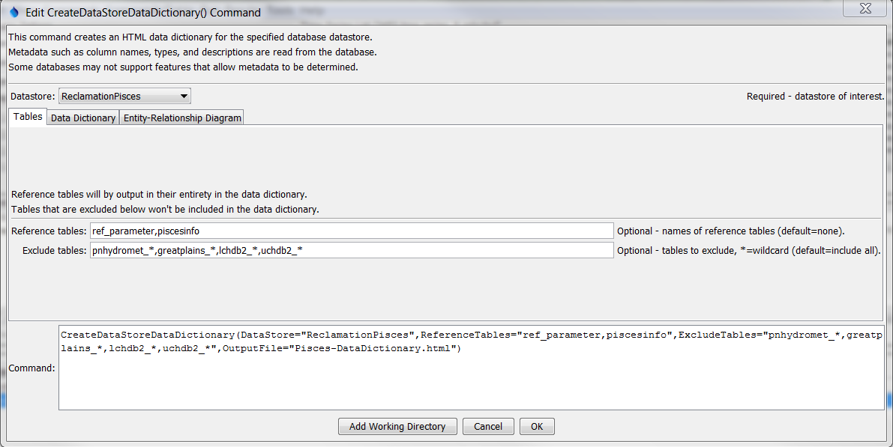

CreateDataStoreDataDictionary_Tables

CreateDataStoreDataDictionary() Command Editor for Table Parameters

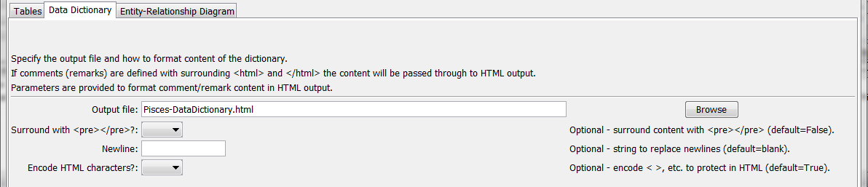

CreateDataStoreDataDictionary

CreateDataStoreDataDictionary() Command Editor for Data Dictionary Parameters

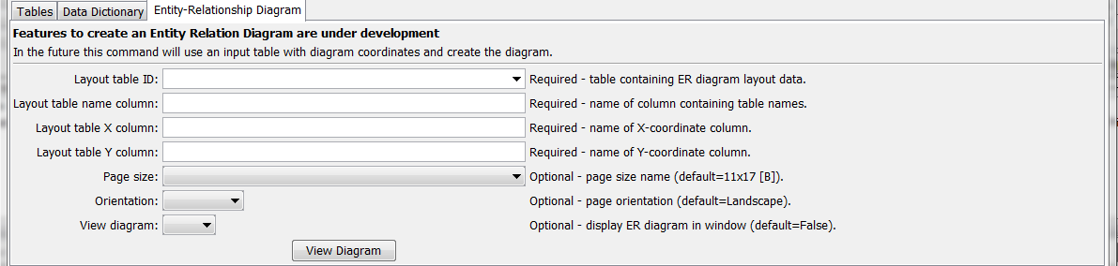

CreateDataStoreDataDictionary_ERDiagram

CreateDataStoreDataDictionary() Command Editor for Entity Relationship Diagram Parameters

The command syntax is as follows:

CreateDataStoreDataDictionary(Parameter=Value,…)

Command Parameters

|  |  |  |
| --- | --- | --- |
| Parameter | Description | Default |
| DataStore | The name of a database datastore. | None – must be specified. |
| ReferenceTables | A list of database reference tables. The content of these tables will be output in their entirety. | No reference tables |
| ExcludeTables | A comma-separated list of tables to exclude from output, for example to exclude database system tables. Use * as a wildcard. | Include all tables. |
| OutputFile | The name of the file for the HTML data dictionary. The name can contain ${Property} notation to insert processor property values in the filename. | None. |
| SurroundWithPre | Specify as True if comments for table columns should be surrounded with <pre></pre> in output, useful if comments included newlines for formatting. In this case Newline and EncodeHtmlChars are ignored. | False |
| Newline | String to replace newline in table column comments. For example use <br> to preserve newlines in HTML output. Specifying True will cause EncodeHtmlChars to be ignored. | Space |
| EncodeHtmlChars | Specify as True if characters such as < should be encoded to display in HTML, False to pass through comment content as is with no encoding. | True |
| ERDiagram  LayoutTableID | The table identifier for the table supplying ER Diagram coordinate information. | None – must be specified if ER Diagram is created. |
| ERDiagramLayout  TableXColumn | The name of the column in the layout table containing the X coordinates for the ER Diagram. Coordinates should be specified in points (1/72 of inch) as position on page size. | None – must be specified. |
| ERDiagramLayout  TableYColumn | The name of the column in the layout table containing the Y coordinates for the ER Diagram. | None – must be specified. |
| ERDiagram  PageSize | The page size for the ER Diagram layout. Currently this defaults to 11x17 (B). | B |
| ERDiagram  Orientation | The orientation of the ER Diagram. | Landscape |
| ViewERDiagram | Indicate whether the ER Diagram should be shown in a window when the commands are run. | False |

The following is an example of an Excel workbook with ER Diagram layout data.

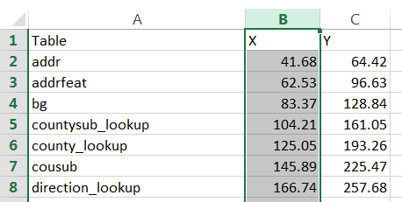

CreateDataStoreDataDictionary_Layout

This page is intentionally blank.