Command Reference: CreateEnsembleFromOneTimeSeries()

Create a new ensemble from a single time series

Version 12.00.00, 2017-04-09

The CreateEnsembleFromOneTimeSeries() command creates an ensemble by splitting up a single time series into traces. For example, a historical time series can be split into 1-year overlapping traces that are shifted to start at the beginning of the current year. The sequence number part of the time series identifier for each trace is set to the year type starting year and will be shown as [Year] at the end of the time series identifier. The data transfer will retain a continuous record. If leap years are encountered, the output may be offset. In other words, no gaps are retained, and no data are discarded due to leap years.

The following dialog is used to edit the command and illustrates the syntax for the command.

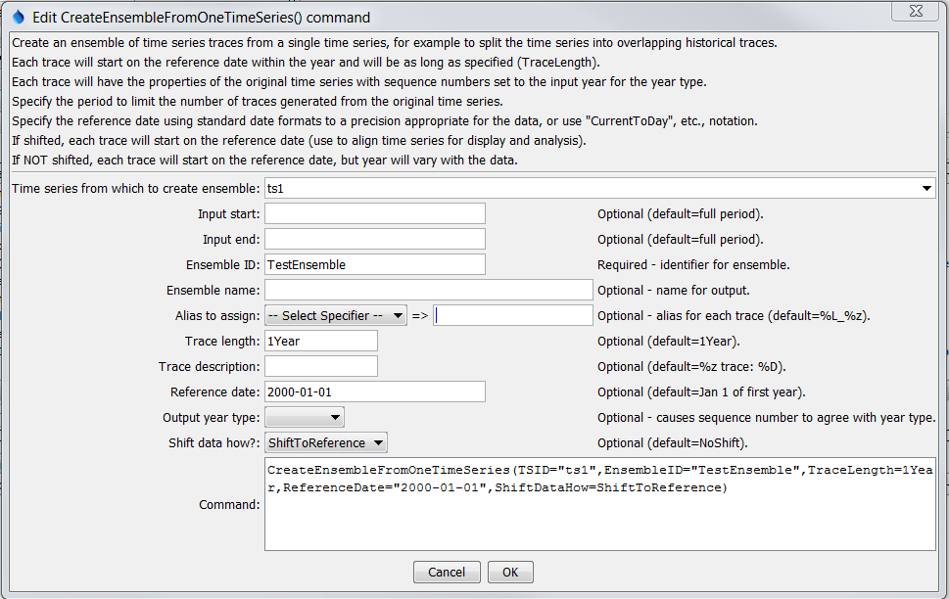

CreateEnsembleFromOneTimeSeries

CreateEnsembleFromOneTimeSeries() Command Editor

The command syntax is as follows:

CreateEnsembleFromOneTimeSeries(Parameter=Value,…)

Command Parameters

| Parameter | Description | Default |
| --- | --- | --- |
| TSID | The time series identifier or alias for the time series used to create the ensemble. Can be specified using ${Property}. | None – must be specified. |
| InputStart | The date/time to start transferring data from the time series. Can be specified using ${Property}. | Use all data. |
| InputEnd | The date/time to end transferring data from the time series. Can be specified using ${Property}. | Use all data. |
| EnsembleID | The new ensemble identifier. Can be specified using ${Property}. | None – must be specified. |
| Ensemble  Name | The name for the new ensemble. Can be specified using ${Property}. | Blank. |
| Alias | The alias to assign to the time series, as a literal string or using the special formatting characters listed by the command editor. The alias is a short identifier used by other commands to locate time series for processing, as an alternative to the time series identifier (TSID). Can be specified using ${Property}. | %L_%z (location_ sequence Number) |
| TraceLength | An interval for the trace length (e.g., 1Year, 1Month or, 7Day). | 1Year |
| Trace  Description | Specify the description to be used for the output traces, using the time series property specifiers %z, etc. | %z trace: %D |
| ReferenceDate | The reference date indicates the starting date for each trace. Each trace optionally can be shifted (see ShiftDataHow), in which case the year in the ReferenceDate is used for the common starting date. The reference date can be one of:   * Blank, indicating that January 1 of the current year will be used. * A date/time string (use the format 01/01/YYYY or YYYY-MM-DD). * CurrentToYear, CurrentToMonth, CurrentToDay, CurrentToHour, CurrentToMinute, indicating the current date/time to the specified precision. * A Current* value +- an interval, for example: CurrentToMinute – 7Day | January 1 of the first year in the source time series. |
| OutputYearType | The output year type for the ensemble traces. The only impact from this parameter is that sequence number for the time series will be set to the start of the output year. This is useful because legends on graphs that use the sequence number (%z format specifier) will use the appropriate year type. The ReferenceDate should normally be specified as the first day of the output year (e.g., ReferenceDate=2012-10-01 for OutputYearType=Water). | Calendar |
| ShiftDataHow | Indicates whether the traces should be shifted. Possible values are:   * ShiftToReference – each trace will be shifted to the reference date, resulting in overlapping time series. * NoShift – plotting the traces will result in a total line that matches the original time series, except that each trace can be manipulated individually. | NoShift |

A sample command file to read a time series from the State of Colorado’s HydroBase and create an ensemble from the time series is as follows:

|  |
| --- |
| # 09019500 - COLORADO RIVER NEAR GRANBY  09019500.USGS.Streamflow.Day~HydroBase  CreateEnsembleFromOneTimeSeries(TSID="09019500.USGS.Streamflow.Day",  TraceLength=1Year,EnsembleID="Ensemble_1",EnsembleName="Test Ensemble",ReferenceDate="2008-01-01",ShiftDataHow=ShiftToReference) |

The following figure illustrates a graph of the resulting ensemble:

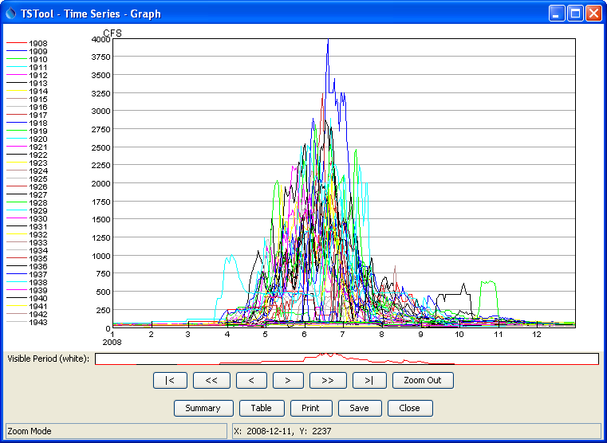

CreateEnsembleFromOneTimeSeries_Graph

CreateEnsembleFromOneTimeSeries() Example Graph

This page is intentionally blank.