Command Reference: CreateTimeSeriesEventTable()

Create a table that contains events associated with time series

Version 10.23.00, 2013-09-09

The CreateTimeSeriesEventTable() command creates an event table associated with time series. Time series events have the following properties:

* EventID – unique identifier for the event
* EventType – event type for the event data (e.g., natural disasters such as drought and flood, economic events, political or legal events)
* EventStart – starting date/time for the event
* EventEnd – ending date/time for the event
* EventLocationType – the type of location (e.g., County, State), used to join the event to time series by location
* EventLocationID – the location identifier (e.g., county name, state abbreviation), used to join the event to time series by location
* EventLabel – short string suitable for labeling a graph or map
* EventDescription – longer string suitable for a narrative description about the event
* TSID – time series identifier to uniquely identify the matching time series

Basic event data are associated with time series using location data to create a “time series event”, which can then be used to annotate time series graph products. The following figure illustrates event data in an Excel worksheet. The column names do not need to be as shown. Location data can be specified in multiple columns, as shown in the far right of the figure, where non-blank values indicate the locations that are applicable for a location type.

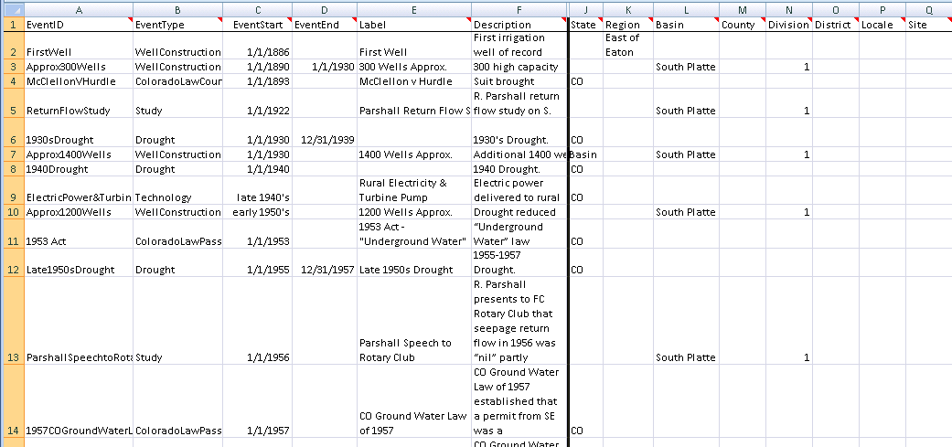

CreateTimeSeriesEventTable_InputTable

Event Data before Relating to Time Series

The following dialog is used to edit the command and illustrates the syntax of the command (in this case illustrating how an input event table can be processed to create a time series event table). It is envisioned that additional methods will be enabled in the future to create time series events, for example to estimate extreme events from data.

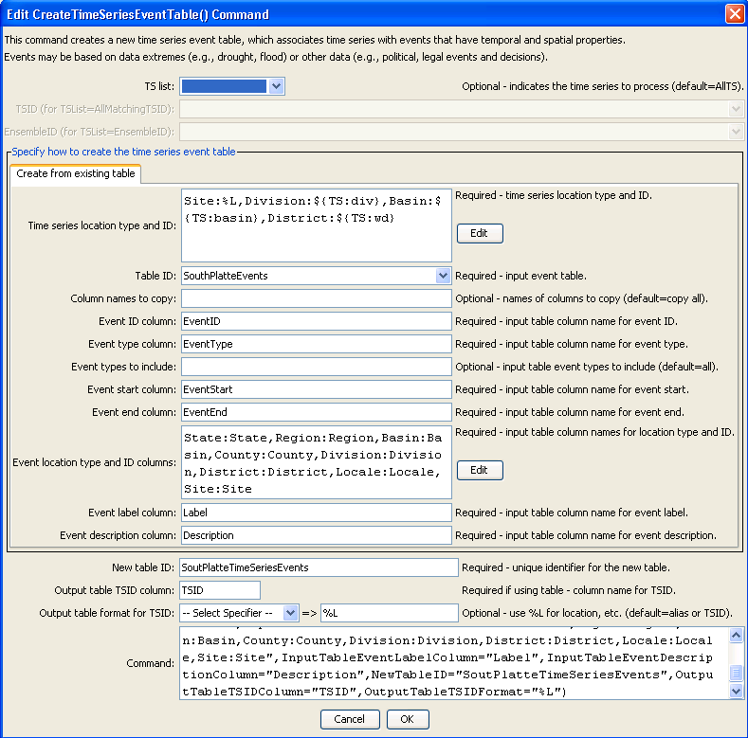

CreateTimeSeriesEventTable

CreateTimeSeriesEventTable() Command Editor

The command syntax is as follows:

CreateTimeSeriesEventTable(Parameter=Value,…)

Command Parameters

| Parameter | Description | Default |
| --- | --- | --- |
| TSList | Indicates the list of time series to be processed, one of:   * AllMatchingTSID – all time series that match the TSID (single TSID or TSID with wildcards) will be processed. * AllTS – all time series before the command. * EnsembleID – all time series in the ensemble will be processed. * FirstMatchingTSID – the first time series that matches the TSID (single TSID or TSID with wildcards) will be processed. * LastMatchingTSID – the last time series that matches the TSID (single TSID or TSID with wildcards) will be processed. * SelectedTS – the time series are those selected with the SelectTimeSeries() command. | AllTS |
| TSID | The time series identifier or alias for the time series to be processed, using the * wildcard character to match multiple time series. | Required if TSList=*TSID. |
| EnsembleID | The ensemble to be processed, if processing an ensemble. | Required if TSList= EnsembleID. |
| TimeSeries  Locations | A dictionary of event location type and time series identifier format specifiers:  LocationType1:Specifier1,LocationType2:Specifier2  The specifiers can use the % formats that are commonly used for time series alias parameters (e.g., %L is location identifier) and also the ${TS:property} syntax that indicates general time series properties. For example, time series location properties are often read when the time series is read, or can be set later with the SetTimeSeriesPropertiesFromTable() command. | None – must be specified. |
| TableID | The identifier for the original event table (which has not been matched with time series). | None – must be specified. |
| IncludeColumns | The names of columns in the TableID table to copy, separated by commas. The required column tables listed below are always copied, but additional columns can be specified. This parameter is not enabled. | Only copy the required columns. |
| InputTable  EventIDColumn | The name of the column in the TableID table containing event identifiers. | None – must be specified. |
| InputTable  EventTypeColumn | The name of the column in the TableID table containing event types. | None – must be specified. |
| Include  InputTable  EventTypes | The event types from the TableID table that should be included when processing (others will be ignored). | Include all event types. |
| InputTable  EventStart  Column | The name of the column in the TableID table containing event start date/time. | None – must be specified. |
| InputTable  EventEndColumn | The name of the column in the TableID table containing event end date/time. | None – must be specified. |
| InputTable  EventLocation  Columns | A dictionary of location types mapped to column names in the TableID table, using syntax:  LocationType1:Column1,LocationType2:Column2 | None – must be specified. |
| InputTable  EventLabel  Column | The name of the column in the TableID table containing event labels. | None – must be specified. |
| InputTable  Event  Description  Column | The name of the column in the TableID table containing event descriptions. | None – must be specified. |
| NewTableID | The identifier for the new time series event table, which will be a join of the TableID table and time series identifier column specified by the OutputTableTSIDColumn. | None – must be specified. |
| OutputTable  TSIDColumn | The name of the column in the NewTableID table containing event types. | None – must be specified. |
| OutputTable  TSIDFormat | The format specifier to be applied to the time series identifier to create the value for the OutputTableTSIDColumn. | None – must be specified. |

The following figure illustrates the result of processing the input event table with a time series that has property basin=South Platte and division=1, which results in 21 of the 55 input rows being used in the output time series event table. The results can then be used when processing time series products to annotate the graphs (see the ProcessTSProduct() command).

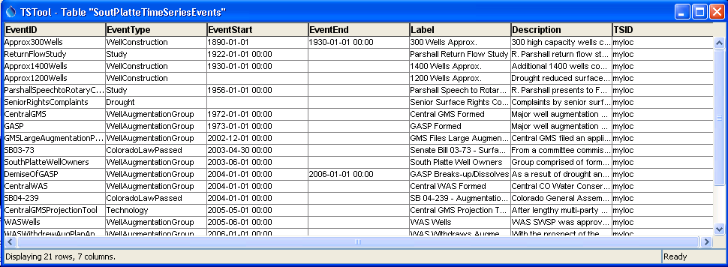

CreateTimeSeriesEventTable_OuputTable

Event Data after Relating to Time Series