Command Reference: Divide()

Divide the data values in one time series by data values in another time series

Version 11.11.01, 2016-05-07

The Divide()command divides one time series by another. This is useful for comparing the relative size of time series values (see also RelativeDiff()). If the divisor is zero or missing, the result is set to missing. Use the Scale() command to divide by a numerical value.

The following dialog is used to edit the command and illustrates the syntax of the command.

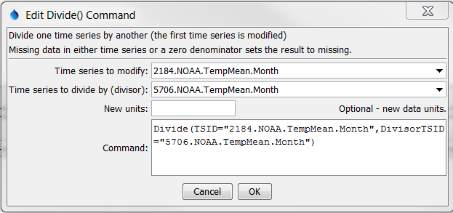

Divide

Divide() Command Editor

The command syntax is as follows:

Divide(Parameter=Value,…)

Command Parameters

|  |  |  |
| --- | --- | --- |
| Parameter | Description | Default |
| TSID | The time series identifier or alias for the time series to be modified. Can specify using ${Property}. | None – must be specified. |
| DivisorTSID | The time series identifier or alias for the time series that is the divisor. Can specify using ${Property}. | None – must be specified. |
| NewUnits | New units to assign to the output time series. Can specify using ${Property}. | Original units will remain. |

A sample command file to process data from the State of Colorado’s HydroBase database is as follows:

|  |
| --- |
| # 2184 - DEL NORTE 2 E  2184.NOAA.TempMean.Month~HydroBase  # 5706 - MONTE VISTA 2 W  5706.NOAA.TempMean.Month~HydroBase  Divide(TSID="2184.NOAA.TempMean.Month",  DivisorTSID="5706.NOAA.TempMean.Month") |

The resulting graph is as follows:

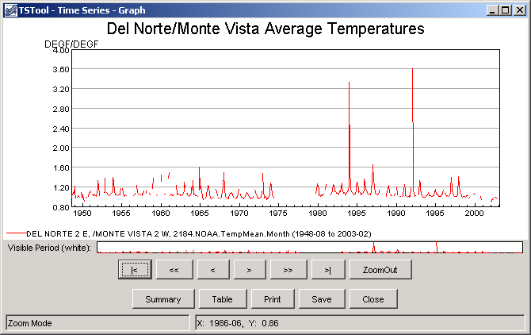

divide_graph

Results from Divide() Command