Command Reference: EndFor()

End a block of commands as part of a “for” loop

Version 10.31.00, 2014-06-29

The EndFor() command ends a block of commands that start with a For() command. The For() and EndFor()commands must have the same value for the Name parameter to allow TSTool to determine the start and end of the block.

The following dialog is used to edit this command and illustrates the command syntax.

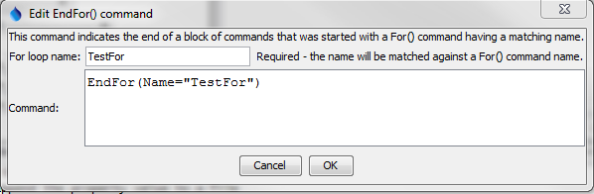

EndFor

EndFor() Command Editor

The command syntax is as follows:

EndFor(Parameter=Value,…)

Command Parameters

|  |  |  |
| --- | --- | --- |
| Parameter | Description | Default |
| Name | The name that will be matched with the name of a For() command to indicate the block of commands in the “for” loop. | None – must be specified. |

This page is intentionally blank.