Command Reference: EndIf()

End a block of commands as part of a conditional “if”

Version 10.26.00, 2013-12-07

The EndIf() command ends a block of commands that start with an If() command. The If() and EndIf()commands must have the same value for the Name parameter to allow TSTool to determine the start and end of the block.

The following dialog is used to edit this command and illustrates the command syntax.

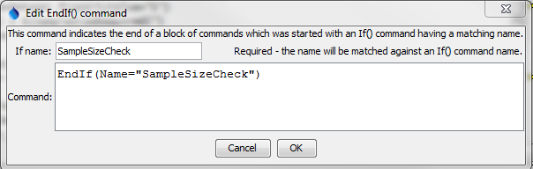

EndIf

EndIf() Command Editor

The command syntax is as follows:

EndIf(Parameter=Value,…)

Command Parameters

|  |  |  |
| --- | --- | --- |
| Parameter | Description | Default |
| Name | The name that will be matched with the name of an If() command to indicate the block of commands in the “if” command. | None – must be specified. |

This page is intentionally blank.