Command Reference: FillConstant()

Fill missing time series data using a constant value

Version 11.02.01, 2015-05-23

The FillConstant() command fills the missing data in a time series with the specified value. This fill technique is useful for filling missing data with zeros, perhaps as the last step in a sequence of filling commands.

The following dialog is used to edit the command and illustrates the command syntax.

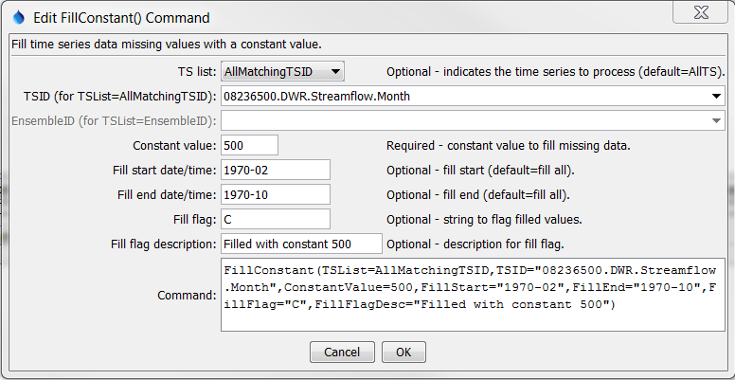

FillConstant

FillConstant() Command Editor

The command syntax is as follows:

FillConstant(Parameter=Value,…)

Command Parameters

|  |  |  |
| --- | --- | --- |
| Parameter | Description | Default |
| TSList | Indicates the list of time series to be processed:   * AllMatchingTSID – all time series that match the TSID (single TSID or TSID with wildcards) will be modified. * AllTS – all time series before the command. * EnsembleID – all time series in the ensemble will be modified. * FirstMatchingTSID – the first time series that matches the TSID (single TSID or TSID with wildcards) will be modified. * LastMatchingTSID – the last time series that matches the TSID (single TSID or TSID with wildcards) will be modified. * SelectedTS – the time series are those selected with the SelectTimeSeries() command. | AllTS |
| TSID | The time series identifier or alias for the time series to be modified, using the * wildcard character to match multiple time series. | Required for TSList=*TSID. |
| EnsembleID | The ensemble to be modified, if processing an ensemble. | Required for TSList=EnsembleID. |
| ConstantValue | Constant value to use when filling missing data. | None – must be specified. |
| FillStart | Date/time indicating the start of filling, using a precision appropriate for the time series, or OutputStart. | Fill the entire time series. |
| FillEnd | Date/time indicating the end of filling, using a precision appropriate for the time series, or OutputEnd. | Fill the entire time series. |
| FillFlag | If specified, data flags will be enabled for the time series and each filled value will be tagged with the specified string. The flag can then be used later to label graphs, etc. The flag will be appended to existing flags if necessary. | No flag is assigned. |
| FillFlagDesc | Description to use for the fill flag. The description is used in visual products such as reports and graphs. | No description is assigned to the fill flag. |

A sample command file to fill a time series from the State of Colorado’s HydroBase is as follows:

|  |
| --- |
| # 08236500 - ALAMOSA RIVER BELOW TERRACE RESERVOIR  08236500.DWR.Streamflow.Month~HydroBase  FillConstant(TSList=AllMatchingTSID,TSID="08236500.DWR.Streamflow.Month",  ConstantValue=500,FillStart="1970-02",FillEnd="1970-10",FillFlag="C") |