Command Reference: FillHistMonthAverage()

Fill missing time series data using historical monthly average data

Version 11.03.07, 2015-06-24

The FillHistMonthAverage() command fills missing data in monthly time series with the average monthly values. The average values are computed using the available data period (or specified averaging period – see the SetAveragePeriod() command) immediately after the time series is read and are then applied when this command is encountered.

The following dialog is used to edit the command and illustrates the syntax of the command.

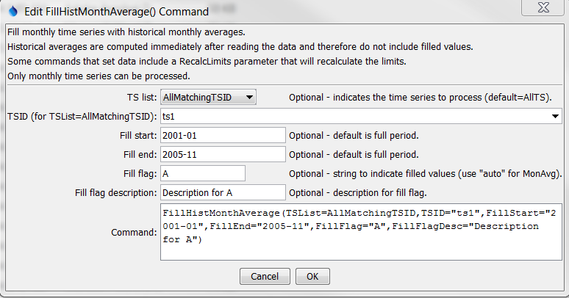

FillHistMonthAverage

FillHistMonthAverage() Command Editor

The command syntax is as follows:

FillHistMonthAverage(Parameter=Value,…)

Command Parameters

| Parameter | Description | Default |
| --- | --- | --- |
| TSList | Indicate how to determine the list of time series to process, one of:   * AllMatchingTSID – process time series that have identifiers matching the TSID parameter. * AllTS – process all the time series. * FirstMatchingTSID – process the first time series that has an identifier matching the TSID parameter. * LastMatchingTSID – process the last time series that has an identifier matching the TSID parameter. * SelectedTS – process the time series that are selected (see SelectTimeSeries()). | None – must be specified. |
| TSID | Used if TSList=AllMatchingTSID to indicate the time series identifier or alias for the time series to be filled. Specify * to match all time series or use a wildcard for one or more identifier parts. Can be specified using processor ${Property}. | Required if TSList=AllMatchingTSID. |
| FillStart | Date/time indicating the start of filling, using a precision appropriate for the time series, or OutputStart. Can be specified using processor ${Property}. | Fill the entire time series. |
| FillEnd | Date/time indicating the end of filling, using a precision appropriate for the time series, or OutputEnd. Can be specified using processor ${Property}. | Fill the entire time series. |
| FillFlag | If specified, data flags will be enabled for the time series and each filled value will be tagged with the specified string. The flag can then be used later to label graphs, etc. The flag will be appended to existing flags if necessary. Use Auto to use a flag with the month abbreviation + Avg. Can be specified using processor ${Property}. | No flag is assigned. |
| FillFlag  Desc | Description for the fill flag, used in reports. Can be specified using processor ${Property}. | Automatically generated. |

The following command files fill a time series from the State of Colorado’s HydroBase:

|  |
| --- |
| # 0125 - ALAMOSA  0125.NOAA.Precip.Month~HydroBase  FillHistMonthAverage(TSList=AllMatchingTSID,TSID=”0125.NOAA.Precip.Month”,  FillFlag=”H”) |

|  |
| --- |
| 0125.NOAA.Precip.Month~HydroBase  FillHistMonthAverage(TSList=AllMatchingTSID,TSID=”019*”,FillFlag=”H”) |

Time series data limits for the averages are printed to the log file, similar to the following examples (note that the period for averaging is always shown and may be different than the output period).

|  |
| --- |
| Status: Historic averages for time series follow...  Time series: 0125.NOAA.Precip.Month (IN)  Monthly limits for period 1948-08 to 1949-12 are:  # % # Not % Not  Month Min MinDate Max MaxDate Sum Miss. Miss. Miss. Miss. Mean  --------------------------------------------------------------------------------------------  Jan 0.2 1949-01 0.2 1949-01 0.2 0 0.00 1 100.00 0.2  Feb 0.1 1949-02 0.1 1949-02 0.1 0 0.00 1 100.00 0.1  Mar 0.1 1949-03 0.1 1949-03 0.1 0 0.00 1 100.00 0.1  Apr -999.0 -999.0 -999.0 1 100.00 0 0.00 -999.0  May -999.0 -999.0 -999.0 1 100.00 0 0.00 -999.0  Jun 0.7 1949-06 0.7 1949-06 0.7 0 0.00 1 100.00 0.7  Jul 1.5 1949-07 1.5 1949-07 1.5 0 0.00 1 100.00 1.5  Aug 0.7 1949-08 0.8 1948-08 1.5 0 0.00 2 100.00 0.8  Sep 0.1 1948-09 1.1 1949-09 1.2 0 0.00 2 100.00 0.6  Oct 0.1 1949-10 0.5 1948-10 0.7 0 0.00 2 100.00 0.3  Nov 0.0 1949-11 0.8 1948-11 0.8 0 0.00 2 100.00 0.4  Dec 0.0 1949-12 0.2 1948-12 0.2 0 0.00 2 100.00 0.1  --------------------------------------------------------------------------------------------  Period 0.0 1949-11 1.5 1949-07 6.9 2 11.76 15 88.24 0.5  -------------------------------------------------------------------------------------------- |