Command Reference: FillInterpolate()

Fill missing time series data by interpolating between known values

Version 11.03.07, 2015-06-24

The FillInterpolate() command fills missing data in a time series by interpolating between known values within the same time series. The command currently will not extrapolate past end points.

The following dialog is used to edit the command and illustrates the syntax of the command.

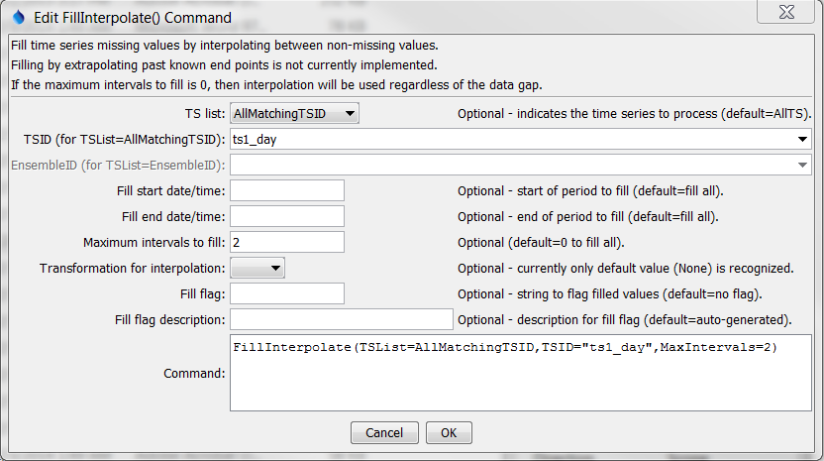

FillInterpolate

FillInterpolate() Command Editor

The command syntax is as follows:

FillInterpolate(Parameter=Value,…)

Command Parameters

| Parameter | Description | Default |
| --- | --- | --- |
| TSList | Indicates the list of time series to be processed, one of:   * AllMatchingTSID – all time series that match the TSID (single TSID or TSID with wildcards) will be modified. * AllTS – all time series before the command. * EnsembleID – all time series in the ensemble will be modified. * FirstMatchingTSID – the first time series that matches the TSID (single TSID or TSID with wildcards) will be modified. * LastMatchingTSID – the last time series that matches the TSID (single TSID or TSID with wildcards) will be modified. * SelectedTS – the time series are those selected with the SelectTimeSeries() command. | AllTS |
| TSID | The time series identifier or alias for the time series to be modified, using the * wildcard character to match multiple time series. Can be specified using processor ${Property}. | Required when TSList=*TSID |
| EnsembleID | The ensemble to be modified, if processing an ensemble. Can be specified using processor ${Property}. | Required when TSList=EnsembleID. |
| FillStart | The starting date/time for the fill. Can be specified using processor ${Property}. | Available period. |
| FillEnd | The ending date/time for the fill. Can be specified using processor ${Property}. | Available period. |
| MaxIntervals | The maximum number of consecutive intervals to fill (0 indicates no limits on the number of consecutive intervals that can be filled). | 0 |
| Transformation | Indicate the data transformation to occur for interpolation. Currently, None is the only option and is the default. Earlier versions used Linear. | None (no transformation). |
| FillFlag | A string to flag data values that are filled. Can be specified using processor ${Property}. | None – do not flag filled data. |
| FillFlagDesc | Description for FillFlag. Can be specified using processor ${Property}. | Auto generated. |

A sample command file using data from the State of Colorado’s HydroBase is as follows:

|  |
| --- |
| # 06707500 - SOUTH PLATTE RIVER AT SOUTH PLATTE  06707500.DWR.Streamflow.Month~HydroBase  FillInterpolate(TSList=AllMatchingTSID,TSID="06707500.DWR.Streamflow.Month",  MaxIntervals=3,Transformation=None) |