Command Reference: FillMOVE2()

Fill missing data in time series using the Maintenance of Variance Extension (MOVE.2) procedure

Version 11.06.01, 2011-07-29

The FillMOVE2() command fills missing data in a time series using the MOVE.2 procedure (see the FillMOVE1() command for background information). The MOVE.2 procedure uses the Two-Station Comparison procedure described in Appendix 7 of Bulletin 17B, Guidelines for Determining Flood Flow Frequency, USGS, to compute improved estimates of the mean and variance at the dependent or short-term station and uses all the data at the dependent time series to estimate the mean and variance of the dependent time series. See also: Hirsch, R. M., 1982, “A Comparison of Four Streamflow Record Extension Techniques”, Water Resources Research, Vol. 18, No. 4, pages 1081-1088. The MOVE.2 procedure has been shown to be marginally better than MOVE.1. The following MOVE.2 equation is used to estimate values for the dependent time series from the independent time series:

**

where

**discharge for dependent time series

**discharge for independent time series

**mean for independent time series for ** years ( N 2 is the additional years in the long-term time series)

**standard deviation for independent time series for ** years

|  |  |
| --- | --- |
|  | (Equation 7-5a for Two-Station Comparison in Appendix 7 of Bulletin 17B) |

**

(Equation 7-10 for Two-Station Comparison in Appendix 7 of Bulletin 17B)

where

**correlation coefficient (Note that b is the slope of the ordinary least squares regression line.)

**concurrent or overlapping period of record

**additional years available at long-term site

**mean of independent time series for **years

**mean of independent time series for **years

**standard deviation of dependent time series for ** years

**standard deviation of independent time series for ** years

The following dialog is used to edit the command and illustrates the command syntax.

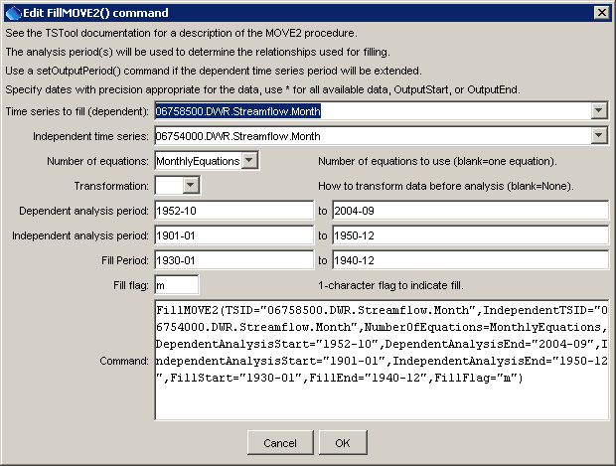

FillMOVE2

FillMOVE2() Command Editor

The command syntax is as follows:

FillMOVE2(Parameter=Value,…)

Command Parameters

|  |  |  |
| --- | --- | --- |
| Parameter | Description | Default |
| TSID | The time series identifier or alias for the time series to be filled (dependent time series). | None – must be specified. |
| IndependentTSID | The time series identifier or alias for the independent time series, to supply data. | None – must be specified. |
| NumberOf  Equations | OneEquation or MonthlyEquations, indicating how many relationships are to be determined. | OneEquation |
| Transformation | Log or None, indicating the type of data transformation. If the Log option is used, zero and negative values are set to .001 (-999 values are treated as missing data and are ignored), and the data values are transformed using log10. | None |
| Dependent  Analysis  Start/End | The period for N1 (overlapping data) that is used to analyze the dependent time series. For example, this may be the unregulated period for streamflow data. Typically, this is longer than the independent analysis period. | Analyze the full period. |
| Independent  Analysis  Start/End | The period for N2 (non-overlapping data) that is used to analyze the independent time series. For example, this may be the unregulated period for streamflow data. | Analyze the full period. |
| FillStart | The date/time to start filling. | Fill the full period. |
| FillEnd | The date/time to end filling. | Fill the full period. |
| FillFlag | A single character to be used to flag filled points on graphs and other output. | Do not flag filled data. |

A sample command file illustrating how to fill time series from the State of Colorado’s HydroBase is as follows (MOVE2 and ordinary least squares regression are used to allow comparing the results):

|  |
| --- |
| StartLog(LogFile="Results/commands.TSTool.log",Suffix="Date")  SetOutputPeriod(OutputStart="1901-01",OutputEnd="2004-12")  # 06758500 - SOUTH PLATTE RIVER NEAR WELDONA  06758500.DWR.Streamflow.Month~HydroBase  # 06754000 - SOUTH PLATTE RIVER NEAR KERSEY  06754000.DWR.Streamflow.Month~HydroBase  FillMOVE2(TSID="06758500.DWR.Streamflow.Month",  IndependentTSID="06754000.DWR.Streamflow.Month",  NumberOfEquations=MonthlyEquations,DependentAnalysisStart="1952-10",  DependentAnalysisEnd="2004-09",IndependentAnalysisStart="1901-01",  IndependentAnalysisEnd="1950-12",FillStart="1930-01",  FillEnd="1940-12",FillFlag="m")  # 06758500 - SOUTH PLATTE RIVER NEAR WELDONA  06758500.DWR.Streamflow.Month~HydroBase  # 06754000 - SOUTH PLATTE RIVER NEAR KERSEY  06754000.DWR.Streamflow.Month~HydroBase  FillRegression(TSID="06758500.DWR.Streamflow.Month",  IndependentTSID="06754000.DWR.Streamflow.Month") |