Command Reference: FillPattern()

Fill missing time series data using historical average patterns

Version 11.03.10, 2015-06-29

The FillPattern()command fills missing data in a time series using historical averages based on a pattern file. For example, if May 1910 is missing and the pattern indicates that May 1910 is a WET month, then the average of all WET Mays is used to fill the time series. The pattern file indicates the WET/DRY/AVG patterns and the time series to be filled supplies data to compute averages, for use in filling. **This feature is enabled for monthly data only**. Averages are computed as described for the FillHistMonthAverage() command. There is currently no way to limit the fill operation to a period (the entire time series is filled). The pattern file is created with the AnalyzePattern() command and a saved file must be read with a ReadPatternFile() command. See below for an example of a fill pattern file. One or more patterns can be included in each pattern file, similar to StateMod time series files (see the StateMod Input Type appendix), and multiple pattern files can be used, if appropriate.

# Years Shown = Water Years

# Missing monthly data filled by the Mixed Station Method, USGS 1989

# Time series identifier = 09034500.CRDSS_USGS.QME.MONTH.1

# Description = COLORADO RIVER AT HOT SULPHUR SPRINGS, CO.

# -e-b----------eb------eb------eb------eb------eb------eb------eb------eb------eb------eb------eb------eb------eb--------e

10/1908 - 9/1996 ACFT WYR

1909 09034500 AVG AVG AVG WET WET AVG AVG AVG WET WET WET WET

1910 09034500 WET WET WET WET WET WET AVG AVG AVG AVG AVG AVG

1911 09034500 AVG AVG WET AVG AVG AVG AVG WET WET WET AVG WET

1912 09034500 WET WET WET WET WET AVG AVG WET WET WET WET WET

...ommitted...

The following dialog is used to edit the FillPattern() command and illustrates the syntax of the command.

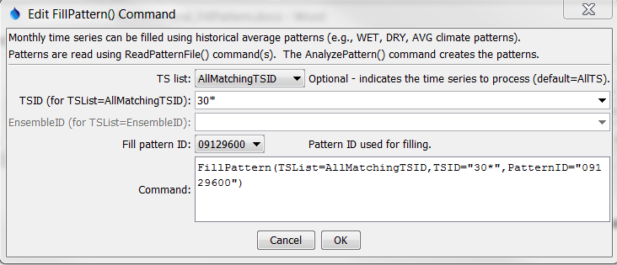

FillPattern

FillPattern() Command Editor

The command syntax is as follows:

FillPattern(Parameter=Value,…)

Command Parameters

|  |  |  |
| --- | --- | --- |
| Parameter | Description | Default |
| TSList | Indicates the list of time series to be processed, one of:   * AllMatchingTSID – all time series that match the TSID (single TSID or TSID with wildcards) will be modified. * AllTS – all time series before the command. * EnsembleID – all time series in the ensemble will be modified. * FirstMatchingTSID – the first time series that matches the TSID (single TSID or TSID with wildcards) will be modified. * LastMatchingTSID – the last time series that matches the TSID (single TSID or TSID with wildcards) will be modified. * SelectedTS – the time series are those selected with the SelectTimeSeries() command. | AllTS |
| TSID | The time series identifier or alias for the time series to be modified, using the * wildcard character to match multiple time series. Can be specified with processor ${Property}. | Required for TSList=*TSID. |
| EnsembleID | The ensemble to be modified, if processing an ensemble. Can be specified with processor ${Property}. | Required for TSList=EnsembleID. |
| PatternID | The pattern identifier, matching a pattern read with ReadPatternFile() commands. | None – must be specified. |

A sample command file to process data from the State of Colorado’s StateMod model is as follows:

|  |
| --- |
| # Read StateMod time series to fill  ReadStateMod(InputFile="..\StateMod\sjm_prelim.ddh")  # Read the file containing the patterns  ReadPatternFile(PatternFile="fill.pat")  # Fill time series having identifiers that start with "30"  FillPattern(TSList=AllMatchingTSID,TSID="30*",PatternID="09034500")  # Write the results  WriteStateMod(TSList=AllTS,OutputFile="..\StateMod\sjm.ddh") |

The above example fills all diversion time series with identifier starting with 30, using the pattern 09034500 (a stream gage for the region).