Command Reference: FillRepeat()

Fill missing time series data by repeating known data values

Version 11.11.01, 2016-06-07

The FillRepeat() command fills missing data in time series by repeating observations until another observation is found. This fill technique is useful, for example, where time series are likely to be step-wise or nearly constant, such as some reservoir and diversion time series.

The following dialog is used to edit the command and illustrates the syntax of the command.

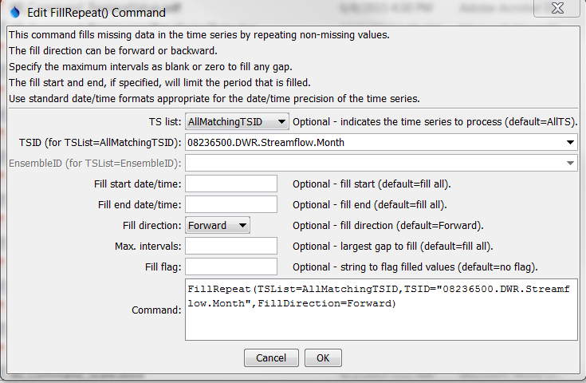

FillRepeat

FillRepeat() Command Editor

The command syntax is as follows:

FillRepeat(Parameter=Value,…)

Command Parameters

| Parameter | Description | Default |
| --- | --- | --- |
| TSList | Indicates the list of time series to be processed, one of:   * AllMatchingTSID – all time series that match the TSID (single TSID or TSID with wildcards) will be modified. * AllTS – all time series before the command. * EnsembleID – all time series in the ensemble will be modified. * LastMatchingTSID – the last time series that matches the TSID (single TSID or TSID with wildcards) will be modified. * SelectedTS – the time series are those selected with the SelectTimeSeries() command. | AllTS |
| TSID | The time series identifier or alias for the time series to be modified, using the * wildcard character to match multiple time series. Can be specified using processor ${Property}. | Required if TSList=*TSID |
| EnsembleID | The ensemble to be modified, if processing an ensemble. Can be specified using processor ${Property}. | Required if TSList= EnsembleID |
| FillStart | The starting date/time for the fill. Can be specified using processor ${Property}. | Available period. |
| FillEnd | The ending date/time for the fill. Can be specified using processor ${Property}. | Available period. |
| FillDirection | Specify the direction of the fill as Forward or Backward. | Forward |
| MaxIntervals | The maximum number of intervals to fill in a data gap. | Fill all gaps. |
| Flag | String to flag filled values. Prefix with + to append the string to existing flag values. Can be specified using processor ${Property}. | Do not flag filled values. |

A sample command file to fill a time series from the State of Colorado’s HydroBase is as follows:

|  |
| --- |
| # 08236500 - ALAMOSA RIVER BELOW TERRACE RESERVOIR  08236500.DWR.Streamflow.Month~HydroBase  FillRepeat(TSList=AllMatchingTSID,TSID="08236500.DWR.Streamflow.Month",  FillDirection=Forward) |