Command Reference: For()

Start a block of commands as part of a “for” loop

Version 11.03.01, 2015-06-06

The For() command iterates through a block of commands between For() and matching EndFor() commands. A processor property is set to the value of the iteration property and can be used by other commands that support properties, using the ${Property} notation. This command is an alternative to implementing loops in templates (see ExpandTemplateFile()), in particular for straightforward command logic. Currently For() commands can iterate over a list of supplied values or values from a table column. For() commands can be nested. Status messages for run mode are accumulated in each command.

The following dialog is used to edit this command and illustrates the command syntax.

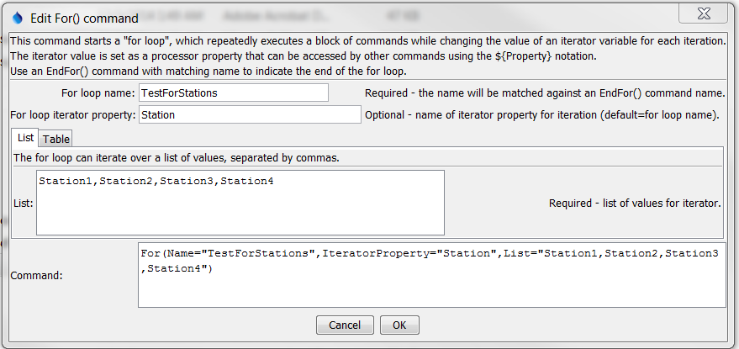

For_List

For() Command Editor Illustrating Using a List for Iteration Values

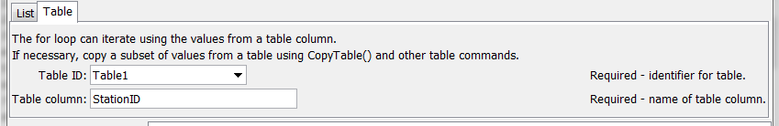

For_Table

For() Command Editor Illustrating Using a Table for Iteration Values

The command syntax is as follows:

For(Parameter=Value,…)

Command Parameters

| Parameter | Description | Default |
| --- | --- | --- |
| Name | The name of the “for” loop, which will be matched with the name of an EndFor() command to indicate the block of commands in the loop. | None – must be specified. |
| IteratorProperty | The processor property that will be set to the iterator property. The object type will depend on that used to provide the iteration property list. For example, if a column of strings from a table is used for iteration, the property will contain a string. | Same as Name. |
| List | A list of comma-separated values to be used as variables for the iteration. | None – must specified a list or table. |
| TableID | The table identifier, when specifying the iterator as a column from a table. Can be specified with processor ${Property}. | None – must specified a list or table. |
| TableColumn | The table column name, when specifying the iterator as a column from a table. | None – must be specified if table is used. |

The following example illustrates a simple For() and EndFor() usage. In this example the StationID column in the input table is used to provide the list of values to iterate over. The following input table is a delimited file but could come from another source:

# Test table data for For() command tests

"Count","Val","StationID","Basin"

1,1.0,Station1,Basin1

2,2.0,Station2,Basin2

3,3.0,Station3,Basin3

4,4.0,Station4,Basin4

The following command file reads the above input table, iterates over the StationID column, and creates a simple output file:

|  |
| --- |
| ReadTableFromDelimitedFile(TableID="Table1",InputFile="Data\testtable.csv")  RemoveFile(InputFile="Results/Test_For_TableString_out.txt",IfNotFound=Ignore)  For(Name="TestFor",TableID="Table1",TableColumn="StationID")  WritePropertiesToFile(OutputFile="Results/Test_For_TableString_out.txt",  IncludeProperty="TestFor",WriteMode=Append,FileFormat=NameTypeValue)  EndFor(Name="TestFor") |

The resulting output file is as follows:

TestFor="Station1"

TestFor="Station2"

TestFor="Station3"

TestFor="Station4"