Command Reference: FormatDateTimeProperty()

Format a date/time property as a new string property

Version 12.00.00, 2017-03-25

The FormatDateTimeProperty() command creates a new processor property by formatting an existing date/time property. These properties are accessible to commands using ${Property} notation. A formatted date/time string is useful when specifying filenames more dynamically. Date/time properties will by default be formatted using the ISO 8061 format (e.g., YYYY-MM-DD hh:mm:ss). Support for properties varies by command and command documentation should be consulted.

The following dialog is used to edit this command and illustrates the syntax of the command.

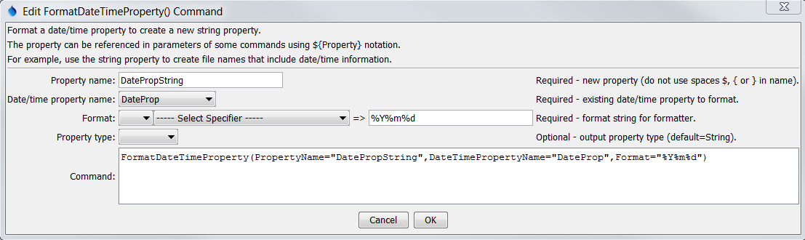

FormatDateTimeProperty

FormatDateTimeProperty() Command Editor

The command syntax is as follows:

FormatDateTimeProperty(Parameter=Value,…)

Command Parameters

| Parameter | Description | Default |
| --- | --- | --- |
| PropertyName | The name of the string property to be created. | None – must be specified. |
| DateTimePropertyName | The name of the existing date/time property to be formatted. | None – must be specified. |
| FormatterType | The date/time formatter type, which defines the format specifiers, one of:   * C – the C programming language strftime() function, which has been widely copied (described below). * MS – Microsoft convention (currently not supported but may be added in the future). | C |
| Format | The format string for the formatter, which defines how date/time data parts are formatted into the new string property. The string is interpreted by the formatter as follows:   * Formatter=C – The string can contain literal characters and format specifiers that start with the % character. | None – must be specified. |
| PropertyType | Indicate the output property type, which allows the command to create properties other than strings. The formatted string must have an appropriate value to allow the conversion:   * Boolean – string must be true or false (case-insensitive) * DateTime – string must be a standard date/time format such as supported by SetProperty() * Double – floating point number * Integer – integer number * String – any text | String |

The following table lists the supported formatting strings for FormatterType=C:

Supported C (Strftime) Formatting Specifiers

|  |  |
| --- | --- |
| Format Specifier | Description |
| %a | Weekday abbreviation (e.g., Sun) |
| %A | Weekday (e.g., Sunday). |
| %b | Month abbreviation (e.g., Jan). |
| %B | Month (e.g., January). |
| %d | Day (01-31). |
| %H | Hour (00-23). |
| %I | Hour (01-12). |
| %j | Day of year (001-366). |
| %m | Month (01-12). |
| %M | Minute (00-59). |
| %p | AM, PM (noon=PM, midnight=AM). |
| %S | Second (00-59). |
| %y | Year (00-99). |
| %Y | Year (0000-9999). |
| %Z | Time zone (e.g., MST). |

A sample command file is as follows:

|  |
| --- |
| SetProperty(PropertyName="DateTimeProp",PropertyType=DateTime,  PropertyValue="CurrentToSecond")  FormatDateTimeProperty(PropertyName="DateTimePropString",  DateTimePropertyName="DateTimeProp",Format="%Y-%m-%dT%H:%M:%S") |