Command Reference: FormatTableDateTime()

Format a date/time column in a table

Version 11.03.00, 2015-05-31

The FormatTableDateTime() command formats a date/time input column from a table to create a table output column. For example, it may be necessary to reformat a date/time column into an object type that is more suitable for reporting, further processing, or export to a spreadsheet. See also the FormatTableString() command. Formatting occurs as follows:

1. The specified date/time column is formatted into a string using the format specifier string specified by the FormatterType and DateTimeFormat parameters. Missing values in input will result in blanks (nulls) in output.
2. The resulting string can be converted to another column type (e.g., an integer or double) by specifying the OutputType parameter.

The following dialog is used to edit the command and illustrates the syntax of the command.

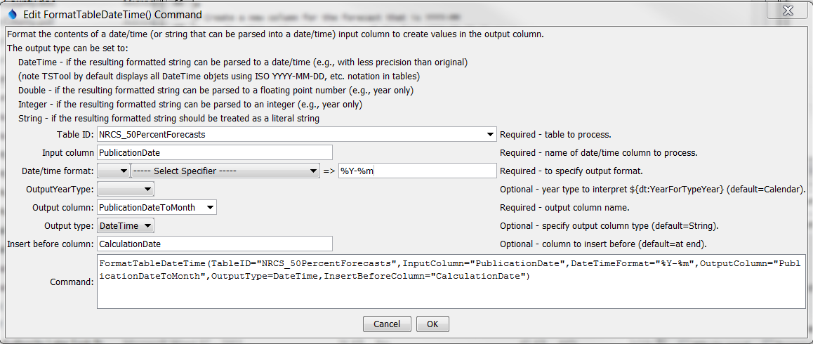

FormatTableDateTime

FormatTableDateTime() Command Editor

The command syntax is as follows:

FormatTableDateTime(Parameter=Value,…)

Command Parameters

| Parameter | Description | Default |
| --- | --- | --- |
| TableID | The identifier for the table to process. Can be specified using processor ${Property}. | None – must be specified. |
| InputColumn | The name of the input date/time column to process. The column can contain date/time objects or strings that can be parsed into date/time objects. Can be specified using processor ${Property}. | None – must be specified. |
| FormatterType | The date/time formatter type that defines DateTimeFormat:   * C – the C programming language strftime() function, which has been widely copied (described below). * MS – Microsoft convention (currently not supported but may be added in the future). | C |
| DateTimeFormat | The format specifier string used to format the date/time values. Specify as many format specifiers as appropriate. All other characters will be transferred to the output string. See the table below for valid specifiers. Can be specified using processor ${Property}. | None – must be specified. |
| OutputYearType | Indicate the year type used to transform the date/time to an output. For example, specify OutputYearType=Water and DateTimeFormat=${dt:YearForYearType} to output the water year corresponding to the input date/time. |  |
| OutputColumn | The name of the column to receive the output. If the column does not exist in the table it will be created, considering OutputType. Can be specified using processor ${Property}. | None – must be specified. |
| OutputType | Specify if the output column should be other than a String. Successful conversion to the output type requires that the format string result is consistent with the desired output type. | String |
| InsertBefore  Column | The name of the column before which the output column should be inserted (if the output column needs to be created). Can be specified using processor ${Property}. | Insert at the end of the table. |

The following table lists the supported format strings for FormatterType=C:

Supported C (Strftime) Format Specifiers

|  |  |
| --- | --- |
| Format Specifier | Description |
| %a | Weekday abbreviation (e.g., Sun) |
| %A | Weekday (e.g., Sunday). |
| %b | Month abbreviation (e.g., Jan). |
| %B | Month (e.g., January). |
| %d | Day (01-31). |
| %H | Hour (00-23). |
| %I | Hour (01-12). |
| %j | Day of year (001-366). |
| %m | Month (01-12). |
| %M | Minute (00-59). |
| %p | AM, PM (noon=PM, midnight=AM). |
| %S | Second (00-59). |
| %y | Year (00-99). |
| %Y | Year (0000-9999). |
| %Z | Time zone (e.g., MST). |
| ${dt:YearForYearType} | 4-digit year for the given OutputYearType. |