Command Reference: Free()

Free (remove) time series from memory

Version 12.00.00, 2017-03-23

The Free() command frees (removes) the selected time series from memory. The time series will therefore not be available for use after that line in the command file. This command is useful for discarding temporary time series needed for data manipulation (e.g., so that they are not written in output and are not available for interactive plots). Freed time series are also removed from any ensembles that reference the time series.

Rather than freeing time series, it may be more appropriate to use the SelectTimeSeries() command, which can be used in conjunction with some commands to select time series and then operate on the selected time series. This approach allows selective use of time series and minimized the need for Free() commands. Many commands also use a TSList parameter to indicate which time series should be operated on by a command. The Free() command is useful if a block of commands is used with For() because many time series may be created.

The following dialog is used for editing the command and illustrates the command syntax.

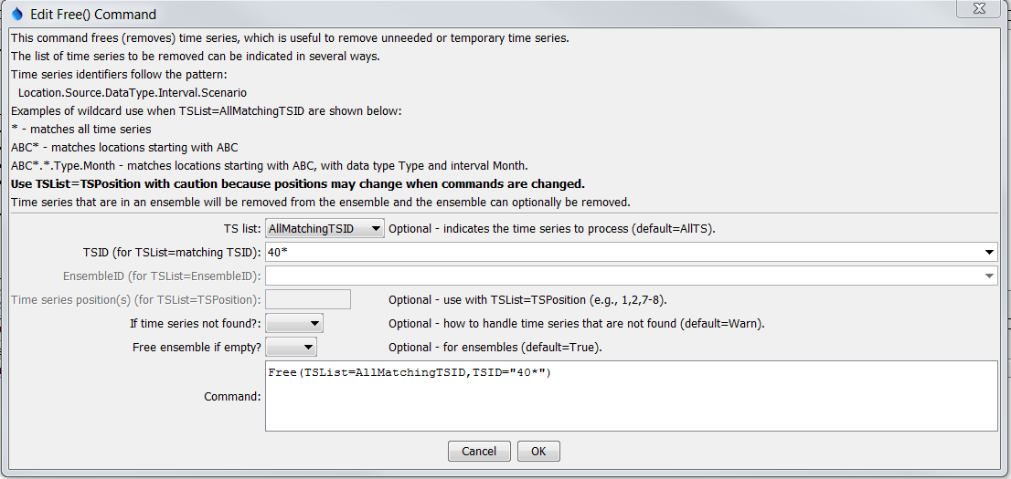

Free

Free() Command Editor

The command syntax is as follows:

Free(Parameter=Value,…)

Command Parameters

|  |  |  |
| --- | --- | --- |
| Parameter | Description | Default |
| TSList | Indicates the list of time series to be processed, one of:   * AllMatchingTSID – all time series that match the TSID (single TSID or TSID with wildcards) will be modified. * AllTS – all time series before the command. * EnsembleID – all time series in the ensemble will be modified (see the EnsembleID parameter). * LastMatchingTSID – the last time series that matches the TSID (single TSID or TSID with wildcards) will be modified. * TSPosition – time series specified by position in the results list (see TSPosition parameter below). | AllTS |
| TSID | The time series identifier or alias for the time series to be modified, using the * wildcard character to match multiple time series. Can be specified using ${Property}. | Required if TSList=*TSID |
| EnsembleID | The ensemble to be modified, if processing an ensemble. Can be specified using ${Property}. | Required if TSList=EnsembleID |
| TSPosition | A list of time series positions (1+) in output, separated by commas. Ranges can be specified as Start-End. | Required if TSList=TSPosition |
| IfNotFound | If a time series is not found to free, indicate the action to take:   * Ignore – ignore * Fail – generate a failure status * Warn – generate a warning status | Warn |
| FreeEnsembleIfEmpty | Indicate whether to free the ensemble from which time series were removed, if the ensemble is empty (has no time series remaining after the Free() command). | True |