Command Reference: If()

Start a block of commands as part of a conditional “if”

Version 10.29.00, 2014-05-18

The If() command evaluates a conditional statement and if true will result in the commands between If() and matching EndIf() being executed (the Name parameter must match). Currently, there is no “else if” or “else” syntax. The syntax for the conditional statement is restricted to:

Value1 operator Value2

Where the values can be integers or integer processor properties and the operator is one of the following (more functionality will be added in the future):

* <
* <=
* >
* >=
* == (use this to test equality – do not use a single equal sign)
* !=

If() commands can be nested. All nested If() commands must evaluate to true to execute the commands within the deepest level of nesting. Some commands, including SelectTimeSeries(), CopyTable(), and ReadTimeSeriesList() now set a property that can be used for checks. The following dialog is used to edit this command and illustrates the command syntax.

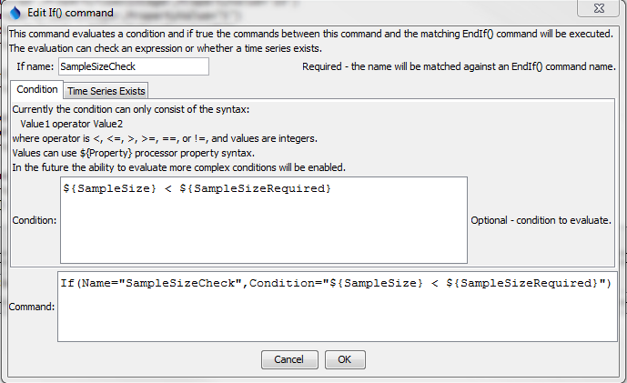

If

If() Command Editor Showing Condition to Test

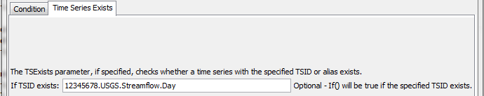

If_TS

If() Command Editor Showing Check for Time Series Existence

The command syntax is as follows:

If(Parameter=Value,…)

Command Parameters

|  |  |  |
| --- | --- | --- |
| Parameter | Description | Default |
| Name | The name of the “if” command, which will be matched with the name of an EndIf() command to indicate the block of commands in the “if” command. | None – must be specified. |
| Condition | The conditional statement to evaluate. | Condition and/or TSExists must be specified. |
| TSExists | Specify a TSID or alias to match. | Condition and/or TSExists must be specified. |

The following example illustrates combinations of If() and Message() commands (indentation indicates line continuation). In these examples processor properties are used to provide condition values.

|  |
| --- |
| # Test evaluating an integer condition where integer is supplied by property  #@expectedStatus Warning  StartLog(LogFile="Results/Test_If_IntegerProperty_LT_IntegerProperty.TSTool.log")  SetProperty(PropertyName="SampleSizeRequired",PropertyType=Integer,  PropertyValue="10")  SetProperty(PropertyName="SampleSize",PropertyType=Integer,PropertyValue="5")  If(Name="SampleSizeCheck",Condition="${SampleSize} < ${SampleSizeRequired}")  Message(Message="Sample size (${SampleSize}) is less than required  ${SampleSizeRequired}",CommandStatus=WARNING)  EndIf(Name="SampleSizeCheck")  If(Name="SampleSizeCheck2",Condition="${SampleSize} > ${SampleSizeRequired}")  Message(Message="Sample size (${SampleSize}) is >= than required  ${SampleSizeRequired}",CommandStatus=WARNING)  EndIf(Name="SampleSizeCheck2")  If(Name="SampleSizeCheck3Outer",Condition="${SampleSize} < ${SampleSizeRequired}")  If(Name="SampleSizeCheck3InnerTrue",Condition="${SampleSize} == 5")  Message(Message="Sample size (${SampleSize}) is == 5",CommandStatus=WARNING)  EndIf(Name="SampleSizeCheck3InnerTrue")  If(Name="SampleSizeCheck3InnerFalse",Condition="${SampleSize} != 6")  Message(Message="Sample size (${SampleSize}) is not == 6",CommandStatus=WARNING)  EndIf(Name="SampleSizeCheck3InnerFalse")  EndIf(Name="SampleSizeCheck3Outer") |