Command Reference: InsertTableColumn()

Insert a column into a table

Version 11.03.00, 2015-05-31

The InsertTableColumn() command inserts a column into a table. An initial value can be set or use the SetTableValues() command to set values after inserting the column.

The following dialog is used to edit the command and illustrates the syntax of the command

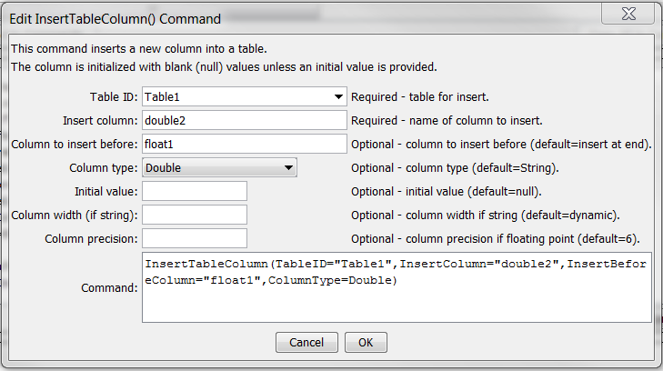

InsertTableColumn

InsertTableColumn() Command Editor

The command syntax is as follows:

InsertTableColumn(Parameter=Value,…)

Command Parameters

| Parameter | Description | Default |
| --- | --- | --- |
| TableID | The identifier for the table being modified. Can be specified using processor ${Property}. | None – must be specified. |
| InsertColumn | The column name to insert. Can be specified using processor ${Property}. | Required |
| InsertBeforeColumn | The name of the column to insert before. Can be specified using processor ${Property}. | Insert at the end of the table |
| ColumnType | The data type for the column, one of:   * DateTime – date/time object * Double – double precision number * Float – single precision number * Integer – integer * Long – long integer * Short – short integer * String – string | String |
| InitialValue | The initial data value to set for the column. For a date/time column use the format YYYY-MM-DD hh:mm or MM/DD/YYYY hh:mm. Can be specified using processor ${Property}. | null |
| ColumnWidth | The column width in characters, if a String column type. | Dynamic sizing |
| ColumnPrecision | The number of digits of precision to show, if a Double or Float column type. | 6 |