Command Reference: InsertTableRow()

Insert 1+ rows in a table

Version 10.27.00, 2014-02-18

The InsertTableRow() inserts 1+ rows in a table. This command has been created to assign blank values for use with the WriteTableCellsToExcel() command, for example to clear out named cells in an Excel workbook. In the future the command will allow setting values in the inserted rows (in the interim, use the SetTableValues() command to assign values to the row after inserting).

The following dialog is used to edit the command and illustrates the syntax of the command

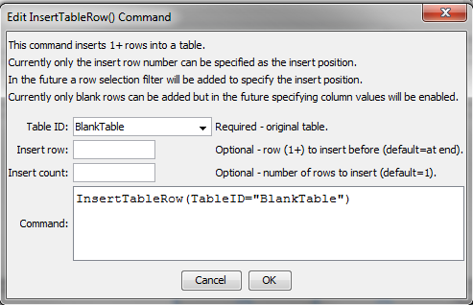

InsertTableRow

InsertTableRow() Command Editor

The command syntax is as follows:

InsertTableRow(Parameter=Value,…)

Command Parameters

| Parameter | Description | Default |
| --- | --- | --- |
| TableID | The identifier for the table being modified. | None – must be specified. |
| InsertRow | The row number (1+) to insert before. | The row will be appended to the end of the table. |
| InsertCount | The number of times the insert should be repeated. | 1 |

This page is intentionally blank.