Command Reference: ListFiles()

List files from a folder and save to a table

Version 10.27.00, 2014-03-10

The ListFiles() command lists files in a folder and saves the list to a table. The table can then be used to drive processes, such as looping with a template. The resulting table will include the following columns:

* FileName – name of the file without leading path
* RelativePath – name of the file as a relative path (relative to the command file working directory)
* AbsolutePath – name of the file as the full absolute path

The following dialog is used to edit the command and illustrates the syntax for the command.

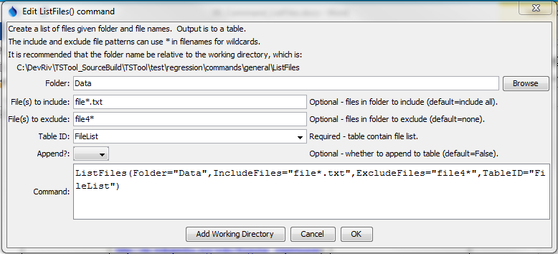

ListFiles

LIstFiles() Command Editor

The command syntax is as follows:

ListFiles(Parameter=Value,…)

Command Parameters

|  |  |  |
| --- | --- | --- |
| Parameter | Description | Default |
| Folder | The name of the folder for which to list files. | None – must be specified. |
| IncludeFiles | A pattern indicating files to include from Folder. Use * in the filename for a wildcard. | All files will be included. |
| ExcludeFiles | A pattern indicating files to exclude from Folder, checked after the IncludeFiles parameter is checked. Use * in the filename for a wildcard. | No files will be excluded. |
| TableID | The identifier for the table to output the list. If the table does not exist, it will be created. See also Append. | None – must be specified. |
| Append | Indicate whether list output should be appended to the table. This allows multiple ListFiles() commands to be used to create a larger list. | False – the table will contain only the current output list. |