Command Reference: Message()

Print a message

Version 10.26.00, 2013-12-07

The Message() command prints a status message to the log file (status level 2). Optionally, the CommandStatus parameter can be used to control the status level for the command, for example to generate a warning or failure status for the command. This command is useful for troubleshooting processing. See also the If() command, which can be used to check for a condition and by using Message() print a message to warn the user.

The following dialog is used to edit this command and illustrates the command syntax.

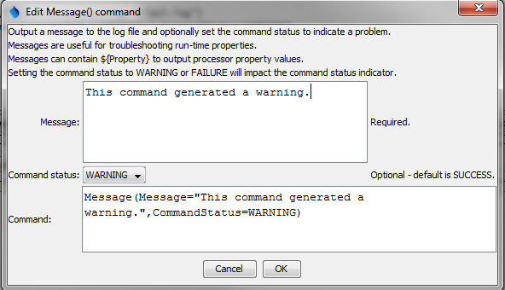

Message

Message() Command Editor

The command syntax is as follows:

Message(Parameter=Value,…)

Command Parameters

|  |  |  |
| --- | --- | --- |
| Parameter | Description | Default |
| Message | The message to print. The text can contain ${Property} notation to expand command processor properties. | Keep previous setting. |
| CommandStatus | The command status that should result from running the command. | SUCCESS |

This page is intentionally blank.