Command Reference: Multiply()

Multiply the data values in a time series by data values in another time series

Version 11.11.01, 2016-06-07

The Multiply()command multiplies one time series by another. Missing data in either time series causes the result to be missing. See also the Scale() command, which multiplies time series by a numerical value.

The following dialog is used to edit the command and illustrates the syntax of the command.

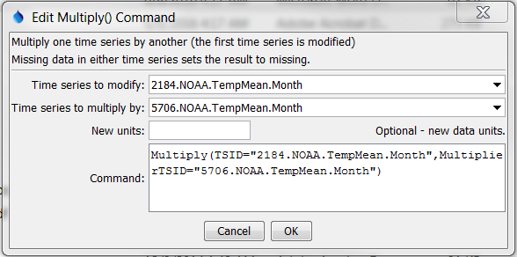

Multiply

Multiply() Command Editor

The command syntax is as follows:

Multiply(Parameter=Value,…)

Command Parameters

|  |  |  |
| --- | --- | --- |
| Parameter | Description | Default |
| TSID | The time series identifier or alias for the time series to be modified. Can specify using ${Property}. | None – must be specified. |
| MultiplierTSID | The time series identifier or alias for the time series that is the multiplier. Can specify using ${Property}. | None – must be specified. |
| NewUnits | Specify the new units to assign. Can specify using ${Property}. | Original units remain. |

A sample command file is as follows (this example does not necessarily make sense but illustrates how the Multiply() command can be used for numerical calculations in an analysis):

|  |
| --- |
| # 2184 - DEL NORTE 2 E  2184.NOAA.TempMean.Month~HydroBase  # 5706 - MONTE VISTA 2 W  5706.NOAA.TempMean.Month~HydroBase  Multiply(TSID="2184.NOAA.TempMean.Month",  MultiplierTSID="5706.NOAA.TempMean.Month") |