Command Reference: NewExcelWorkbook()

Create a new Microsoft Excel workbook file

Version 11.03.01, 2015-06-06

The NewExcelWorkbook() command creates a Microsoft Excel workbook file and optionally also creates worksheets in the new workbook. See also other Excel processing commands that can be used to further manipulate the Excel file.

TSTool uses the Apache POI software (http://poi.apache.org) to write the Excel file and consequently functionality is constrained by the features of that software package.

The following dialog is used to edit the command and illustrates the syntax for the command.

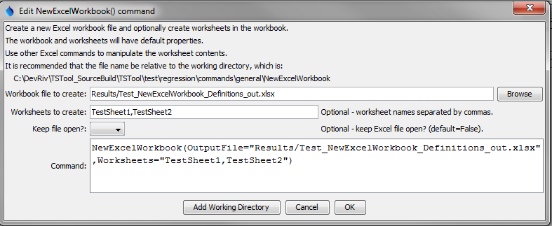

NewExcelWorkbook

NewExcelWorkbook() Command Editor

The command syntax is as follows:

NewExcelWorkbook(Parameter=Value,…)

Command Parameters

| Parameter | Description | Default |
| --- | --- | --- |
| OutputFile | The name of the Excel workbook file (*.xls or *.xlsx) to create, as an absolute path or relative to the command file location. Can specify using processor ${Property}. | None – must be specified. |
| Worksheets | The name(s) of the worksheets to create in the workbook. Can specify using processor ${Property}. | Don’t create any named sheets. |
| KeepOpen | Indicate whether to keep the Excel file open (True) or close after creating (False). Keeping the file open will increase performance because later commands will not need to reread the workbook. Make sure to close the file in the last Excel command. | False |