Command Reference: NewStatisticMonthTimeSeries()

Create a new month interval time series containing a statistic determined from each month of the input time series

Version 10.28.00, 2014-04-07

**This command is under development.**

The NewStatisticMonthTimeSeries() command creates a new month interval time series, where each monthly value in the resulting time series contains a statistic determined from the data sample from the corresponding month in the original time series. For example, if the original time series has a daily time step, then the sample that is analyzed will contain 28-31 values (depending on leap year and month). Other commands (e.g., ChangeInterval()) can produce a similar result for a limited number of statistics, for example converting a monthly time series to an annual total or mean. See also the NewStatisticTimeSeries(), NewStatisticTimeSeriesFromEnsemble(), CalculateTimeSeriesStatistic(), NewStatisticYearTS(), and CheckTimeSeries() commands.

For hourly and finer interval, values are considered to be in a month when the month in the date/time matches the month of interested. This may lead to some issues if the last value in a month is actually recorded at hour 0 or later of the following month. **Handling other than daily data is not yet implemented**.

The following dialog is used to edit the command and illustrates the syntax for the command.

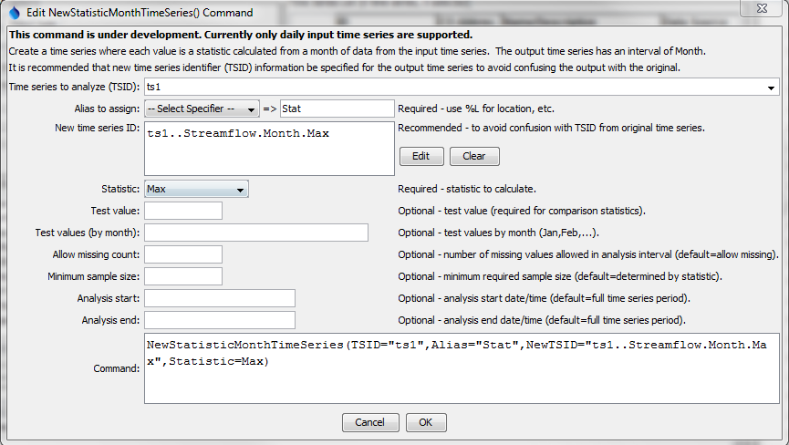

NewStatisticMonthTimeSeries

NewStatisticMonthTimeSeries() Command Editor

The command syntax is as follows:

NewStatisticMonthTimeSeries(Parameter=value,…)

Command Parameters

| Parameter | Description | Default |
| --- | --- | --- |
| TSID | The time series identifier (or alias) of the time series to analyze. In the future this command will support processing multiple time series. | None – must be specified. |
| Alias | The alias to assign to the output time series, as a literal string or using the special formatting characters listed by the command editor (which will use properties of the input time series). The alias is a short identifier used by other commands to locate time series for processing, as an alternative to the time series identifier (TSID). | None – must be specified. |
| NewTSID | The time series identifier to be assigned to the new time series, which is useful to avoid confusion with the original time series. | Use the same identifier as the original time series, with an interval of Month and a scenario matching the statistic. |
| Statistic | See the Available Statistics table below. | None – must be specified. |
| TestValue | A test value used when analyzing the statistic. | This parameter is required for some statistics and not used for others. See the statistics table below. |
| MonthTest  Values | Twelve monthly test values separated by commas, with January’s value first. | Single test value will be used. |
| AllowMissing  Count | The number of missing values allowed in the source interval(s) in order to produce a result. | Allow any number of missing values. |
| Minimum  SampleSize | The minimum sample size in order to compute the statistic. | No minimum, although the statistic may have requirements. |
| AnalysisStart | The starting date/time for the analysis using calendar dates (e.g., 2001-01), with month precision. This will limit the data being analyzed and defines the output period. | Analyze the full period, extending the period to include full months. |
| AnalysisEnd | The starting date/time for the analysis using calendar dates (e.g., 2001-01), with month precision. This will limit the data being analyzed and defines the output period. | Analyze the full period, extending the period to include full months. |

Available Statistics

The following statistics are computed from a sample determined from each of data from the input time series.

| Statistic | Description | Limitations |
| --- | --- | --- |
| DayOfCentroid | The day of the month (1-31) that is the centroid of the values, computed as sum(DayOfMonth*value)/sum(values). | Input time series must be daily or smaller interval. |
| DayOfFirstGE | Day of the month (1-31) for the first data value >= TestValue. | Input time series must be daily or smaller interval. |
| DayOfFirstGT | Similar to DayOfFirstGE, for values > TestValue. | Input time series must be daily or smaller interval. |
| DayOfFirstLE | Similar to DayOfFirstGE, for values <= TestValue. | Input time series must be daily or smaller interval. |
| DayOfFirstLT | Similar to DayOfFirstGE, for values < TestValue. | Input time series must be daily or smaller interval. |
| DayOfLastGE | Day of the month (1-31) for the last data value >= TestValue. | Input time series must be daily or smaller interval. |
| DayOfLastGT | Similar to DayOfLastGE, for values > TestValue. | Input time series must be daily or smaller interval. |
| DayOfLastLE | Similar to DayOfLastGE, for values <= TestValue. | Input time series must be daily or smaller interval. |
| DayOfLastLT | Similar to DayOfLastGE, for values < TestValue. | Input time series must be daily or smaller interval. |
| DayOfMax | Day of the month (1-31) for the first maximum value in the time series. | Input time series must be daily or smaller interval. |
| DayOfMin | Day of the month (1-31) for the first minimum value in the time series. | Input time series must be daily or smaller interval. |
| GECount | Count of values in a month >= TestValue. |  |
| GEPercent | Percent of values in a month >= TestValue, based on the total number of points in the month. |  |
| GTCount | Count of values in a month > TestValue. |  |
| GTPercent | Percent of values in a month > TestValue, based on the total number of points in the month. |  |
| LECount | Count of values in a month <= TestValue. |  |
| LEPercent | Percent of values in a month <= TestValue, based on the total number of points in the month. |  |
| LTCount | Count of values in a month < TestValue. |  |
| LTPercent | Percent of values in a month < TestValue, based on the total number of points in the month. |  |
| Max | Maximum value in a month. |  |
| Mean | Mean of values in a month. |  |
| Min | Minimum value in a month. |  |
| MissingCount | Number of missing values in a month. |  |
| MissingPercent | Percent of missing values in a month. |  |
| NonMissingCount | Number of non-missing values in a month. |  |
| NonMissingPercent | Percent of non-missing values in a month. |  |
| Total | Total of values in a month. |  |