Command Reference: NewTable ()

Create a new table

Version 11.03.03, 2015-06-10

The NewTable() command creates a table with named columns, each of which is a specified data type. Tables are used to hold information about data objects, such as statistics for time series. Commands like CalculateTimeSeriesStatistic() can add information to tables. Tables can be written as final data products or artifacts of processing. Characteristics of the table are as follows:

* Each column can only contain a single data type
* The default precision for numbers for display and output is 2 digits after the decimal – additional formatting features may be available in write commands and may be added later
* Tables are referenced using the TableID
* Cells in tables are referenced using the column name and cell values that identify rows (such as time series identifiers)

The following dialog is used to edit the command and illustrates the syntax for the command.

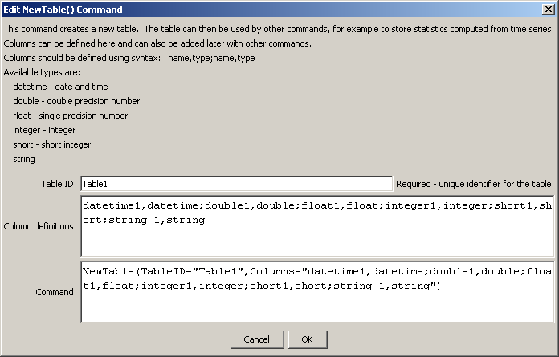

NewTable

NewTable () Command Editor

The command syntax is as follows:

NewTable (Parameter=Value,…)

Command Parameters

|  |  |  |
| --- | --- | --- |
| Parameter | Description | Default |
| TableID | Identifier for the table – should be unique among tables that are defined. Can be specified using processor ${Property}. | None – must be specified. |
| Columns | The column names and data types are defined using the format ColumnName,DataType; ColumnName,DataType. Column names can contain spaces; however, simple short names are generally handled better by display features and minimize errors in referencing the columns. Data types are specified using the following strings:   * datetime – date and time * double – double precision number * float – single precision number * integer – integer (-2147483648 to 2147483647) * short – short integer (-32768 to 32767) * string – Unicode string | No columns will be defined. |